 

**A**

**Project Report**

on

**Automate Diagnosis & Consultants (ADC)**

submitted for partial fulfillment for the award of

**BACHELOR OF TECHNOLOGY**

**DEGREE**

SESSION 2022-23

in

**Computer Science**

By

Ankit Yadav (1900290120016)

Ayush Srivastava (1900290120029)

**Under the Supervision of**

Dr. Harsh Khatter Assistant Professor

Department of Computer Science  
  
**KIET Group of Institutions, Ghaziabad**  
Affiliated to  
**Dr. A.P.J. Abdul Kalam Technical University, Lucknow**(Formerly UPTU)

**May, 2023**

# DECLARATION

We hereby declare that this submission is our work and that, to the best of our knowledge and belief, it contains no material previously published or written by another person nor material that to a substantial extent has been accepted for the award of any other degree or diploma of the university or other institute of higher learning, except where due acknowledgment has been made in the text.

Signature of Students

Name: Ankit Yadav

Roll No.: 1900290120016

Name: Ayush Srivastava

Roll No.: 1900290120029

Date: 25/05/2023

# CERTIFICATE

This is to certify that the Project Report entitled “**Automate Diagnosis & Consultant”** which is submitted by **Ankit Yadav and Ayush Srivastava** in partial fulfillment of the requirement for the award of degree B. Tech. in the Department of Computer Science of Dr A.P.J. Abdul Kalam Technical University, Lucknow is a record of the candidates own work carried out by them under my supervision. The matter embodied in this report is original and has not been submitted for the award of any other degree.

Date: 25/05/2023

##### Supervisor Signature

Dr. Harsh Khatter

Assistant Professor

Department of Computer Science

# ACKNOWLEDGEMENT

#### It gives us great pleasure to present the Project Report of the B. Tech Major Project undertaken during the B.Tech. Fourth Year. We owe a special debt of gratitude to Dr. Harsh Khatter, Assistant Professor, Department of Computer Science, KIET Group of Institutions, Delhi- NCR, Ghaziabad, for his constant support and guidance throughout the course of our work. His sincerity, thoroughness, and perseverance have been a constant source of inspiration for us. It is only his/her cognizant efforts that our endeavors have seen the light of day.

We also take the opportunity to acknowledge the contribution of Dr. Ajay Kumar Shrivastava, Head of the Department of Computer Science, KIET Group of Institutions, Delhi- NCR, Ghaziabad, for his full support and assistance during the development of the project. We also do not want to miss the opportunity to acknowledge the contribution of all the department’s faculty members for their kind assistance and cooperation during the development of our project.

#### Last, but not least, we acknowledge our friends for their contribution to the completion of the project.

Signature:

#### Name: Ankit Yadav

Roll No.: 1900290120016

#### Name: Ayush Srivastava Roll No.:1900290120029

Date: 25/05/2023

# ABSTRACT

A sizable segment of the world's population lacks access to quality healthcare. The success of healthcare ultimately depends on the doctor's skill. In this study, we investigate if this knowledge may be represented as an information corpus, or as data that has been retrieved using data mining methods, particularly the Machine Learning & Deep Learning Model, to make a diagnosis. When the medical diagnosis is made widely available, coverage increases, and life quality improves. To determine whether inferences about the causes of various diseases can be made from the data, this project provides an overview of machine learning approaches used in the classification of various diseases. We outline a few of our findings from the trials we ran before offering some suggestions for the future.

The difference between the current state of health and an acceptable or desirable health condition is the health problem. By lowering doctor visits, hospital stays, and diagnostic testing procedures, monitoring systems are designed to lower healthcare expenditures. Using the data mining modeling technique, the integration of clinical decision support with computer-based patient records could decrease medical errors, increase patient safety, stop unwelcome practice variance, and improve practice outcomes. Connecting patients and doctors through a user-friendly interface will make it easier for patients to use in emergency situations.

|  |  |  |
| --- | --- | --- |
| **TABLE OF CONTENTS** | |  |
|  | | Page No. |
|  | |  |
| DECLARATION .............................................................................................................. | | ii |
| CERTIFICATE …........................................................................................................... | | iii |
| ACKNOWLEDGEMENT.................................................................................................. | | iv |
| ABSTRACT...................................................................................................................... | | v |
| TABLE OF CONTENT .................................................................................................... | | vi-vii |
| LIST OF FIGURES .................................................................................................... | | viii |
| LIST OF TABLES………………………………………………………………........... | | ix |
| CHAPTER 1 INTRODUCTION | | 1-5 |
| 1.1. | Introduction ……………………................................................... | |
| 1.2 | Problem Statement.……………………....................................... | |
| 1.3 | Field Of Innovation……………………………………………… | |
| 1.4 | Objective………………………………………………………… | |
| 1.5 | Scope……………………………………………………………. | |
| 1.6 | Advantage………………………………………………………. | |

CHAPTER 2 REQUIREMENT ANALYSIS AND SYSTEM SPECIFICATION …….. 6-12

|  |  |  |
| --- | --- | --- |
| 2.1. | Feasibility Study ……………………................................................... |  |
| 2.2 | Software Analysis Specification Document.…………...................... |  |
| 2.3. | Prototype Model to be used………………………………………… |  |
| 2.4. | Scope……………………………………………………………. |  |

#### CHAPTER 3 SYSTEM DESIGN ………………………………….............................. 13-28

|  |  |
| --- | --- |
| 3.1. | Detail Design ……………………................................................... |
| 3.2 | UML Diagram.…………................................................................. |
|  |  |
|  |  |

#### CHAPTER 4 IMPLEMENTATION………………………………………………………... 29-37

|  |  |  |
| --- | --- | --- |
| 4.1. | Algorithm for Proposed System …………………................................. |  |
| 4.2 | Proposed System of ADC……………………...…………...................... |  |
| 4.3. | Implementation Activity……...………………………………………... |  |
| 4.4 | Technology Used …………………….................................................... |  |

CHAPTER 5 RESULTS AND DISCUSSIONS....................................................................... 38-48

|  |  |
| --- | --- |
| 5.1. | User Interface ……………………........................................................ |
| 5.2 | Snapshots Of Different Modules………………………………………. |

#### CHAPTER 6 CONCLUSION & FUTURE SCOPE…............................................................ 49

#### LIST OF PUBLICATION…………………………………………………………………… 50-51

REFERENCES…..................................................................................................................... 52-53

RESEARCH PAPER……………………………………………………………………….... 54-59

|  |  |  |
| --- | --- | --- |
|  | **LIST OF FIGURES** |  |
|  | Page no. |
| Fig 3.1 | Component Diagram | 15 |
| Fig 3.2 | Activity Diagram (Path Lab module) | 16 |
| Fig 3.3 | Activity Diagram (Doctors module) | 17 |
| Fig 3.4 | Activity Diagram (Patients module) | 18 |
| Fig 3.5 | Data Flow Diagram (Level-0) | 19 |
| Fig 3.6 | Data Flow Diagram (Level-1 Patient module) | 20 |
| Fig 3.7 | Entity Relationship Diagram | 21 |
| Fig 3.8 | Login Module | 22 |
| Fig 3.9 | Forgot Password Module | 23 |
| Fig 3.10 | Use Case Diagram of patient & doctor module | 24 |
| Fig 3.11 | Use Case Diagram of path lab & admin module | 25 |
| Fig 3.12 | Data Streaming Model | 26 |
| Fig 3.13 | Use case model of the Frontend link with ML model | 28 |
| Fig 4.1 | Machine Learning Algorithm’s flow chart | 31 |
| Fig 4.2 | System flow Diagram | 34 |
| Fig 5.1 | User Interface of Project | 38 |
| Fig 5.2 | Disease Prediction Modules | 38 |
| Fig 5.3 | Various modules of the project | 39 |
| Fig 5.4 | Snapshots of the Consultant web application | 40 |
| Fig 5.5 | Snapshots of the Login Module | 41 |
| Fig 5.6 | Snapshots of Doctor Search Module | 42 |
| Fig 5.7 | Snapshots of Lung Cancer Prediction Module | 43 |
| Fig 5.8 | Snapshots of Multiple Disease Prediction Module | 44 |
| Fig 5.9 | Snapshots of Add Patient Module of Automate Diagnosis | 45 |
| Fig 5.10 | Snapshots of Add Doctor Module of Automate Diagnosis | 46 |
| Fig 5.11 | Snapshots of Add & Get Report Module via Patient ID & Doctor ID | 47 |
| Fig 5.12 | Snapshots of Report added by Path Labs in Decentralized format. | 48 |

**LIST OF TABLES**

PAGE NO

TABLE 4.1 LIST OF ALGORITHMS USED 32

**CHAPTER 1**

**INTRODUCTION**

* 1. **Introduction:**

The health problem is the gap between acceptable or desirable health status and the present status. In today’s life, health problems occurred more than last 25-30 years ago because of modernization, and industrialization. Suddenly, changes in the environment directly affect a health condition. So, more health-related problems are occurring day by day and require daily checkups on health conditions. This project is based on real-time implementation as well as more informative and realistic it can be highly used in Medical Diagnosis and understanding the different feasibilities of the model.

The growth of ML has facilitated the increased use of computers in medicine. There are three primary goals of data mining that tend to be prediction, description, and presentation. Prediction involves some variables or fields in the dataset to predict unknown or future values of other variables of interest. The description focuses on finding patterns describing the data that can be interpreted by humans, on the other hand, Presentation plays an important role to be easily understandable to humans.

Health issues are more prevalent today than they were 25 to 30 years ago due to urbanization and industrialization. Unexpected changes in the environment have a direct impact on health. As a result, more health issues emerge daily, necessitating daily health condition checks. This project, which is based on real-time implementation and is more informative and realistic, can be very useful in helping to diagnose medical conditions.

The goal of creating automated systems is to decrease the amount of time and money spent on health care by lowering the number of doctor visits, hospital stays, and diagnostic testing procedures. The second main method is supervised learning, which uses machine learning techniques to learn a function from a collection of training data. Prediction and generalization are two key requirements for supervised learning algorithm performance. The trained function ought to be capable of accurately predicting the results for data that are not included in the training set. It should also serve as a model that generalizes to new data points and captures the underlying traits of the training data.

## Problem Statement:

In such unprecedented times, with a fragile healthcare infrastructure, medical facilities for people are scarce, and even fewer for people with special needs. The healthcare sector got so preoccupied with Covid-19 cases that people with other ailments didn't even get a chance to avail medical assistance. So, we are here to present a model to mitigate the scarcity of facilities & the lack of medical management.

The current healthcare system faces several challenges related to disease prediction, doctor recommendations, online consultation and appointment scheduling, and the management of patient records. These challenges can lead to inefficiencies, delays in diagnosis, and compromised patient care. Therefore, there is a need for an Automated Diseases Prediction System, Doctor Recommendation System, Online Consultation/Appointment with Labs/Doctors, and decentralized patient records. The problem statement can be summarized as follows:

**Automated Diseases Prediction System:**

Current diagnostic processes heavily rely on manual evaluation, which can be time-consuming and prone to human errors. There is a need for an automated system that can accurately predict multiple diseases based on patient symptoms and medical history, providing healthcare professionals with timely and accurate diagnostic support.

**Doctor Recommendation System:**

Patients often face challenges in finding the most suitable doctor for their specific medical condition. A doctor recommendation system is required to help patients identify and connect with the right healthcare providers based on their specialty, expertise, location, and patient reviews. This system should provide personalized recommendations to ensure patients receive appropriate care.

**Online Consultation/Appointment with Labs/Doctors:**

Traditional in-person consultations and appointment scheduling can be inconvenient and time-consuming for patients. There is a need for an online platform that enables patients to schedule consultations, book appointments with doctors or laboratories, and have virtual consultations for non-emergency medical issues. This system should provide a seamless and user-friendly interface for patients to access healthcare services remotely.

**Path-labs Booking:**

Booking appointments and accessing diagnostic services at path labs or diagnostic centers can be a cumbersome process. There is a need for an online system that allows patients to book appointments for laboratory tests, receive timely notifications, and securely access their test results. This system should streamline the process of diagnostic testing and enhance the patient experience.

**Decentralized Patient Records:**

Centralized patient record systems can lead to issues such as data breaches, lack of interoperability, and limited patient control over their medical data. There is a need for a decentralized patient record system based on blockchain technology, ensuring data security, and privacy, and giving patients ownership and control over their medical records. This system should enable seamless sharing of patient records among healthcare providers while maintaining data integrity and patient confidentiality.

* 1. **Field of Invention:**

The field of invention for Automate Diagnosis & Consultant falls under the domain of healthcare technology and artificial intelligence. It combines advancements in machine learning, data analysis, and medical expertise to automate the diagnosis of diseases and provide consultation to patients or healthcare professionals. This field aims to improve the efficiency and accuracy of disease diagnosis by leveraging computational algorithms and data-driven models. It also facilitates remote consultations, enhances decision-making processes, and provides valuable insights for healthcare providers. The invention of Automate Diagnosis & Consultant has the potential to revolutionize healthcare by leveraging technology to support and augment the capabilities of medical professionals, ultimately leading to improved patient care and outcomes.

The technology related to the general field of healthcare and management, i.e., machine learning-based automated medical diagnosis enhances healthcare infrastructure. The difference between the current state of health and an acceptable or desirable health condition is the health problem. By lowering doctor visits, hospital stays, and diagnostic testing procedures, monitoring systems are designed to lower healthcare expenditures.

## Objectives:

The objective of developing an automated system is to change the way to present and detection of any diagnosis by

**Improve Accuracy and Efficiency:** The primary objective is to develop a system that can accurately diagnose diseases based on patient symptoms and medical data. By leveraging machine learning algorithms and data analysis techniques, the system aims to enhance the accuracy of diagnoses and reduce the time required for diagnosis, ultimately improving patient outcomes.

**Facilitate Early Detection and Treatment:** Early detection of diseases significantly increases the chances of successful treatment. The system aims to identify diseases at their early stages by analyzing symptoms and medical history. This objective is crucial for timely intervention and providing appropriate treatment options to patients.

**Provide Decision Support for Healthcare Professionals:** The system should act as a valuable tool for healthcare professionals by providing them with reliable and data-driven insights. It aims to assist doctors in making informed decisions, suggesting potential diagnoses, and recommending appropriate treatment plans based on medical evidence and best practices.

**Enhance Remote Healthcare Delivery:** The system should enable remote consultations and healthcare delivery, allowing patients to receive expert medical advice without the need for physical visits. This objective aims to improve access to healthcare services, especially for individuals in remote areas or those with limited mobility.

**Improve Patient Engagement and Education:** The system should engage patients in their healthcare journey by providing them with personalized information, educational resources, and explanations regarding their diagnoses and treatment options. This objective aims to empower patients to actively participate in their healthcare decisions and enhance their overall understanding of their medical conditions.

**Ensure Data Privacy and Security:** Patient data privacy and security are of utmost importance in healthcare systems. The objective is to develop robust security measures to protect patient information and ensure compliance with privacy regulations such as HIPAA or GDPR. The system should utilize encryption, access controls, and secure data storage mechanisms to safeguard sensitive medical data.

**Foster Collaboration and Knowledge Sharing**: The system should facilitate collaboration and knowledge sharing among healthcare professionals. It aims to provide a platform for experts to share insights, discuss complex cases, and exchange medical knowledge, ultimately improving the collective expertise in diagnosing and treating diseases.

**Continual Learning and Improvement**: The system should be designed to continuously learn and improve over time. It should incorporate mechanisms to update and refine its algorithms based on new medical research, diagnostic guidelines, and user feedback. This objective ensures that the system remains up-to-date and maintains high diagnostic accuracy.

There are some objectives are as follows:

* + - Reduce health care costs by reducing physical hospital visits. hospitalizations, and diagnostic testing procedures.
    - Integrate doctors with patients’ disease prediction with relevant doctor suggestions.
    - Automated Diseases Prediction System to make facilities available easily.

## Scope:

The project focuses on developing algorithms and models that can accurately diagnose a wide range of diseases based on patient symptoms and medical data. The scope includes the identification and analysis of relevant symptoms, medical history, and diagnostic criteria for various diseases.

It involves the collection and integration of patient data from various sources, such as electronic health records (EHRs), medical imaging systems, and laboratory reports. The scope includes designing mechanisms to gather relevant patient information securely and efficiently for accurate diagnosis. It encompasses the development and implementation of machine learning algorithms and data analysis techniques to process and analyze patient data. The scope includes feature extraction, feature selection, model training, and validation to achieve accurate disease prediction.

The project aims to provide consultation and treatment recommendations to patients and healthcare professionals. The scope includes developing an interactive user interface to facilitate communication, presenting diagnostic results, suggesting treatment options, and providing relevant medical information. It involves integrating the Automate Diagnosis & Consultant system with existing healthcare systems, such as EHRs, laboratory information systems, and telemedicine platforms.

The scope includes designing interfaces and APIs to exchange data securely and seamlessly with these systems. Setting up an alarm alert system and adding more diseases to our model increases our feasibility & compatibility with the market. Adding more body parts models that increase people’s knowledge that would lead to training purposes for the nurses.

## Advantages:

* + - Integration of clinical decision support with computer-based patient records could reduce medical errors and enhance patient safety: By integrating clinical decision support systems with computer-based patient records, healthcare providers can access real-time patient information, medical history, and relevant clinical guidelines during diagnosis and treatment. This integration helps reduce medical errors by providing healthcare professionals with valuable decision support, such as drug interaction alerts, allergy warnings, and evidence-based treatment recommendations. By enhancing patient safety, this integration ensures that healthcare providers have access to accurate and up-to-date information, leading to improved clinical outcomes.
    - Unwanted practice variance is eliminated, and practice outcomes are improved: By utilizing an Automate Diagnosis & Consultant system, unwanted practice variance can be minimized. The system follows standardized protocols and clinical guidelines, leading to consistent and evidence-based practices. This consistency helps improve practice outcomes by ensuring that patients receive the same level of care regardless of the healthcare professional they consult. This raises the standard of clinical judgment and reduces the likelihood of errors or inconsistencies in diagnosis and treatment.
    - Reduce disease identification time and start treatment expeditiously: Automated Diseases Prediction Systems can analyze patient symptoms and medical data efficiently, leading to quicker disease identification. By leveraging machine learning and data analysis techniques, the system can rapidly process and analyze large volumes of data to provide timely diagnoses. This allows healthcare providers to start treatment expeditiously, potentially reducing the progression of the disease and improving patient outcomes.
    - Reduce the cost of medical tests: Automate Diagnosis & Consultant systems can assist in reducing the cost of medical tests by providing initial diagnostics in a timely manner. By accurately predicting diseases based on symptoms and medical data, the system can help healthcare providers determine the necessary tests and procedures, avoiding unnecessary and costly investigations. This reduces the financial burden on patients and their families, making healthcare more affordable and accessible.
    - Decentralized Patient Records make data more accessible and enable fast diagnosis: With decentralized patient records, medical information becomes easily accessible to authorized healthcare providers. This accessibility eliminates the need for time-consuming data transfers between healthcare facilities and allows for quick access to patient records during diagnosis. Fast access to comprehensive medical data enhances the speed and accuracy of diagnoses, enabling healthcare professionals to make informed decisions promptly.
    - Integration of doctors and patients via an interactive and user-friendly interface: An interactive and user-friendly interface connects doctors and patients, enabling seamless communication and remote consultations. Patients can easily access the system, seek medical advice and schedule appointments in emergency situations. This integration improves accessibility to healthcare services and enhances the patient experience by providing convenient and efficient means of communication.
    - Research on pharmaceutical equipment and medicines: Conducting research on pharmaceutical equipment and medicines ensures that patients receive access to high-quality and reliable medical supplies. By verifying the authenticity and purity of medicines, patients can have confidence in the medications they receive, regardless of their location.

## CHAPTER 2

## REQUIREMENT ANALYSIS AND SYSTEM SPECIFICATION

**2.1 Feasibility Study (Technical, Economical, Operational)**

The proposed project aims to develop an automated medical diagnosis system using machine learning techniques that will reduce healthcare costs by lowering physical hospital visits, hospitalizations, and diagnostic testing procedures. It will also integrate doctors with patients' disease predictions and suggestions, make facilities easily available, and reduce disease identification time.

The feasibility of the project can be evaluated in terms of technical feasibility, economic feasibility, legal feasibility, and operational feasibility.

##### Technical Feasibility:

The project requires the development of an automated medical diagnosis system using machine learning algorithms, which is technically feasible. There are several tools and frameworks available for developing machine learning models, such as Python's Scikit-learn, TensorFlow, Keras, etc.

##### Economic Feasibility:

The project's economic feasibility depends on several factors such as development cost, operating cost, and revenue generation potential. The project's development cost includes hardware and software infrastructure, development team salaries, and training costs. The operating cost includes maintenance costs, server costs, and cloud services costs. Revenue generation potential could come from subscription-based models, advertisements, or commission-based fees on doctor consultations or pathology tests booked through the platform.

##### Legal Feasibility:

The project should comply with local regulations and laws related to healthcare, patient privacy, and data protection. It should also adhere to ethical guidelines related to patient data collection, storage, and usage.

##### Operational Feasibility:

The project's operational feasibility depends on the user's ability to use the platform easily and the availability of healthcare professionals to respond to patient queries and concerns. It also requires seamless integration with existing healthcare systems to enable access to patient records and avoid duplication of data.

Overall, the project appears to be technically feasible, economically feasible, and legally feasible. However, the operational feasibility may require further testing and development to ensure that it is user-friendly and compatible with existing healthcare systems.

## 2.2 Software Requirement Specification Document

##### Introduction

The purpose of this SRS document is to specify the software requirements for an automated diagnosis and consultant web application. This document will outline the data, functional, performance, maintainability, and security requirements for the application.

##### Data Requirements

The following data requirements must be met by the application:

* + - The ability to collect and store patient health data, including medical history, symptoms, and test results
    - The ability to integrate with existing electronic health record (EHR) systems or other data sources
    - The ability to protect patient data and comply with HIPAA regulations

##### Functional Requirements

The following functional requirements must be met by the application:

* + - The ability to perform automated diagnosis and consultation based on patient data and machine-learning algorithms.
    - The ability to provide personalized treatment recommendations based on the diagnosis
    - The ability to integrate with healthcare providers and allow for secure communication between providers and patients
    - The ability to support multiple languages and accommodate patients from diverse backgrounds

##### Performance Requirements

The following performance requirements must be met by the application:

* + - The ability to handle a high volume of patient data and requests
    - The ability to provide accurate diagnosis and consultation results within a reasonable time frame
    - The ability to maintain high availability and minimize downtime

##### Maintainability Requirements

The following maintainability requirements must be met by the application:

* + - The ability to quickly identify and resolve software bugs or issues
    - The ability to perform software updates and upgrades with minimal disruption to users
    - The ability to provide documentation and training for healthcare providers and patients

##### Security Requirements

The following security requirements must be met by the application:

* + - The ability to protect patient data and comply with HIPAA regulations
    - The ability to prevent unauthorized access to the application and patient data
    - The ability to implement secure authentication and communication protocols between providers and patients

##### Conclusion

This SRS document has outlined the data, functional, performance, maintainability, and security requirements for an automated diagnosis and consultant web application. These requirements must be met in order to ensure the success and viability of the application.

## 2.3 Prototype Model To Be Used in Automate Diagnosis & Consultant Web Application

The Prototype model is an iterative approach to software development that involves building a working prototype of the application to gather feedback and refine the requirements before developing the final product. Here's an example of how the Prototype model could be implemented for an automated diagnosis and consultant web application:

##### 1-Requirements Gathering:

The first step in the Prototype model is to gather and analyze the requirements for the web application. This involves identifying the needs of the healthcare providers and patients, the data sources to be integrated, and the features and functionalities of the application.

##### 2-Initial Prototype Development:

The next step is to develop an initial prototype of the web application that includes the core features and functionalities. This prototype should be a working model of the application that can be tested and evaluated by the stakeholders.

##### 3-Evaluation and Feedback:

Once the initial prototype is developed, it should be evaluated and tested by the stakeholders, including the healthcare providers and patients. Feedback should be gathered from the stakeholders regarding the prototype's functionality, usability, and user interface.

##### 4-Prototype Refinement:

Based on the feedback received, the prototype should be refined and updated to address any issues or concerns raised by the stakeholders. This may involve adding new features, modifying existing ones, or changing the user interface.

##### Repeat Steps 3 and 4:

The evaluation and feedback loop should be repeated until the stakeholders are satisfied with the prototype's functionality and usability. The prototype should be refined and updated based on the feedback received until it meets all the stakeholders' needs.

##### Final Product Development:

Once the stakeholders are satisfied with the prototype, the final product can be developed based on the refined prototype's specifications. The final product should include all the features and functionalities of the prototype and should be thoroughly tested before deployment.

In the case of an automated diagnosis and consultant web application, the Prototype model could be implemented by building an initial prototype that includes the core features such as patient data collection, machine learning algorithms for diagnosis, and personalized treatment recommendations. The prototype could then be evaluated and tested by healthcare providers and patients, and feedback could be gathered to refine and improve the prototype's functionality and usability. The prototype refinement process could involve adding new features such as secure communication between providers and patients, accommodating patients from diverse backgrounds, and integrating with electronic health record (EHR) systems. Once the stakeholders are satisfied with the prototype, the final product could be developed based on the refined prototype's specifications and thoroughly tested before deployment.

**2.4 Requirement Analysis for Automating Diagnosis with Machine Learning to Predict Multiple Diseases**

**2.4.1 User Requirements:**

* The system should accurately predict multiple diseases based on input symptoms and patient data.
* The system should provide recommendations or treatment suggestions based on the predicted diseases.
* The system should be user-friendly and accessible to healthcare professionals or individuals seeking medical advice.
* The system should be able to handle a large volume of data and provide results in a timely manner.
* The system should ensure patient data confidentiality and comply with relevant data protection regulations.

**2.4.2 Functional Requirements:**

* Data Input: The system should accept input in the form of symptoms and patient data, such as age, gender, medical history, and relevant test results.
* Disease Prediction: The system should employ machine learning algorithms to analyze the input data and predict multiple diseases.
* Accuracy and Reliability: The system should have a high accuracy rate in disease prediction and provide reliable results.
* Treatment Recommendations: The system should generate appropriate treatment recommendations or suggestions based on the predicted diseases.
* Integration with Existing Systems: The system should be able to integrate with electronic health record (EHR) systems or other healthcare databases to access patient information.
* Scalability: The system should be capable of handling a growing volume of data and be scalable to accommodate future expansion.
* Real-time Response: The system should provide prompt responses to user queries or inputs.
* Notifications and Alerts: The system should have the capability to send notifications or alerts to healthcare professionals regarding critical or urgent cases.

**2.4.3 Non-Functional Requirements:**

* Performance: The system should have fast response times and be capable of processing large datasets efficiently.
* Security: The system should employ appropriate security measures to protect patient data and prevent unauthorized access.
* Privacy: The system should comply with privacy regulations and ensure the confidentiality of patient information.
* Usability: The system should have an intuitive and user-friendly interface, making it easy for healthcare professionals to input data and interpret results.
* Accuracy and Explain ability: The system should provide transparent explanations or justifications for the predicted diseases to enhance trust and facilitate decision-making by healthcare professionals.
* Maintenance and Support: The system should be maintainable, and technical support should be available to address any issues or concerns.
* Compliance: The system should adhere to relevant regulations and standards in healthcare, such as HIPAA (Health Insurance Portability and Accountability Act).

**2.4.4 Constraints:**

* Availability of Data: Sufficient and diverse training data must be available to train the machine learning models effectively.
* Hardware and Infrastructure: The system may require adequate computational resources and infrastructure to handle the computational demands of machine learning algorithms.
* Regulatory Compliance: The system should comply with healthcare regulations and privacy laws, such as HIPAA, to ensure patient data protection.
* Ethical Considerations: The system should prioritize ethical considerations in handling patient data and avoid biases or discrimination in disease prediction.

**2.4.5 Overall System Architecture:**

The system architecture for automating diagnosis with machine learning to predict multiple diseases would involve several components working together to achieve the desired functionality. The key components of the system architecture are as follows:

* User Interface: This component provides an interface for users (healthcare professionals or individuals seeking medical advice) to input symptoms and patient data. It can be a web-based application, mobile app, or a dedicated software interface.
* Data Collection and Integration: This component handles the collection and integration of data required for disease prediction. It may involve integrating with electronic health record (EHR) systems or other healthcare databases to access patient information, including symptoms, medical history, test results, and demographic data.
* Preprocessing and Feature Extraction: The input data collected from various sources may require preprocessing and feature extraction to convert it into a suitable format for machine learning algorithms. This step involves cleaning the data, handling missing values, normalizing or standardizing features, and extracting relevant features that contribute to disease prediction.
* Machine Learning Models: This component includes the machine learning algorithms responsible for learning patterns from the preprocessed data and making predictions. Various machine learning techniques such as classification algorithms (e.g., decision trees, random forests, support vector machines) or deep learning models (e.g., convolutional neural networks, recurrent neural networks) can be employed to train the models based on historical data.
* Model Training and Evaluation: The machine learning models need to be trained using a labeled dataset, which includes known symptoms and corresponding diagnosed diseases. The training process involves optimizing model parameters to minimize prediction errors. The trained models are then evaluated using appropriate evaluation metrics to assess their performance and ensure their accuracy and reliability.
* Disease Prediction and Treatment Recommendations: Once the models are trained and evaluated, they can be used to predict multiple diseases based on input symptoms and patient data. The system compares the input data with the learned patterns from the training phase and generates disease predictions. It also provides treatment recommendations or suggestions based on the predicted diseases, considering established medical guidelines and best practices.
* Integration with External Systems: The system may need to integrate with external systems such as diagnostic imaging systems or laboratory information systems to access additional diagnostic data, such as radiology images or laboratory test results, to enhance the accuracy of disease predictions.

**2.4.6 Key Considerations and Technologies:**

* Data Storage and Management: The system may require a robust database management system (DBMS) to store and manage patient data securely. This can include relational databases or NoSQL databases based on the specific requirements of the system.
* Scalability and Performance: To handle large volumes of data and ensure real-time response, the system architecture should consider distributed computing frameworks, such as Apache Spark or Hadoop, and employ techniques like parallel processing or data partitioning.
* Machine Learning Frameworks and Libraries: Utilize popular machine learning frameworks and libraries, such as TensorFlow, Keras, or scikit-learn, to implement the machine learning algorithms efficiently. These frameworks provide pre-implemented algorithms, model training utilities, and evaluation metrics.
* Cloud Computing: Cloud platforms like Amazon Web Services (AWS), Google Cloud Platform (GCP), or Microsoft Azure can be leveraged for scalable infrastructure, storage, and computing resources. This allows for flexibility in resource allocation and ensures high availability of the system.
* Privacy and Security: Implement robust security measures, such as data encryption, access controls, and audit logs, to protect patient data and comply with relevant regulations like HIPAA. It is crucial to follow best practices for data anonymization and de-identification to preserve patient privacy.
* User Interface and Visualization: Design a user-friendly interface that facilitates easy input of symptoms and patient data. Consider incorporating data visualization techniques, such as graphs or charts, to present the disease predictions and treatment recommendations in a clear and interpretable manner.

**2.4.7 Model Maintenance and Improvement:**

* Continuous monitoring and evaluation of the machine learning models is essential to maintain their accuracy and effectiveness. The system should include mechanisms for retraining the models periodically using new data and incorporating the latest medical research and guidelines. Feedback loops and user feedback collection can be integrated into the system to improve the models over time and ensure continuous enhancement of disease prediction accuracy.

**2.4.8 Testing and Validation:**

* Rigorous testing and validation should be conducted to ensure the system's performance, reliability, and accuracy. This includes unit testing of individual components, integration testing to verify the interoperability of different modules, and end-to-end testing to assess the overall functionality of the system. Validation should involve comparing the system's predictions against known diagnoses and involving domain experts to assess the clinical relevance and accuracy of the results.

**2.4.9 Ethical Considerations:**

* The system design should prioritize ethical considerations, such as fairness, transparency, and accountability. Steps should be taken to mitigate biases in the data and model predictions, promote transparency by providing explanations or justifications for predictions, and establish clear protocols for handling critical or urgent cases. Regular audits and evaluations should be conducted to ensure compliance with ethical standards and regulations.

## CHAPTER 3

## SYSTEM DESIGN

* 1. **Detail Design**

System design for an automated diagnosis and consultant web application involves defining the architecture, components, and technical specifications of the system. Here are the key components of the system design for the web application:

##### Architecture:

The system architecture defines the overall structure of the web application and how its components interact with each other. The web application could be designed using a client-server architecture, where the client sends requests to the server, and the server processes the requests and sends back the responses.

##### User Interface:

The user interface is the graphical interface that allows users to interact with the web application. The user interface should be designed to be intuitive and user-friendly, and it should provide easy access to all the features and functionalities of the web application.

##### Database:

The database is the backbone of the web application, and it stores all the patient data, diagnosis, and treatment recommendations. The database should be designed to be scalable, secure, and easily accessible to authorized users.

##### Machine Learning Algorithms:

Machine learning algorithms are the heart of the web application, and they are responsible for analyzing patient data and making accurate diagnoses and treatment recommendations. The machine learning algorithms should be trained on large datasets and should be capable of handling complex and diverse patient data.

##### Communication:

The web application should provide secure and reliable communication channels between healthcare providers and patients. This could involve integrating video conferencing, messaging, and other communication tools into the web application.

##### Security:

The web application should be designed with security in mind, and it should be equipped with robust security measures to protect patient data and prevent unauthorized access. This could involve implementing encryption, user authentication, and access control mechanisms.

##### Performance:

The web application should be designed to be highly performant, with fast response times and minimal downtime. This could involve optimizing database queries, using caching mechanisms, and scaling the application horizontally.

##### Integration:

The web application should be designed to integrate with other healthcare systems such as electronic health record (EHR) systems, billing systems, and pharmacy systems.

In summary, the system design for an automated diagnosis and consultant web application involves defining the architecture, user interface, database, machine learning algorithms, communication channels, security measures, performance optimization, and integration with other healthcare systems. The design should be scalable, secure, reliable, and user-friendly, with a focus on providing accurate and personalized diagnosis and treatment recommendations to patients.

**Conclusion:**

The system design for automating diagnosis with machine learning to predict multiple diseases involves several key components working together to achieve accurate disease prediction and provide treatment recommendations. By integrating data collection, preprocessing, machine learning models, and user interfaces, the system can efficiently analyze input symptoms and patient data to predict multiple diseases.

The design incorporates considerations for scalability, performance, privacy, and security to ensure the system can handle large volumes of data, provide real-time responses, protect patient information, and comply with relevant regulations. Integration with external systems, such as diagnostic imaging or laboratory systems, can further enhance the accuracy of disease predictions.

Continuous model maintenance, including retraining with new data and feedback collection, helps improve prediction accuracy over time. Rigorous testing and validation are crucial to ensure the system's performance and reliability, with domain experts validating the clinical relevance and accuracy of the predictions.

Ethical considerations, such as fairness, transparency, and accountability, are embedded in the design to mitigate biases, provide explanations for predictions, and establish protocols for critical cases. Adherence to ethical standards and regulations is vital throughout the system's development and deployment.

## UML Diagrams

Various embodiments of the invention are disclosed in the following detailed description & accompanying drawings:

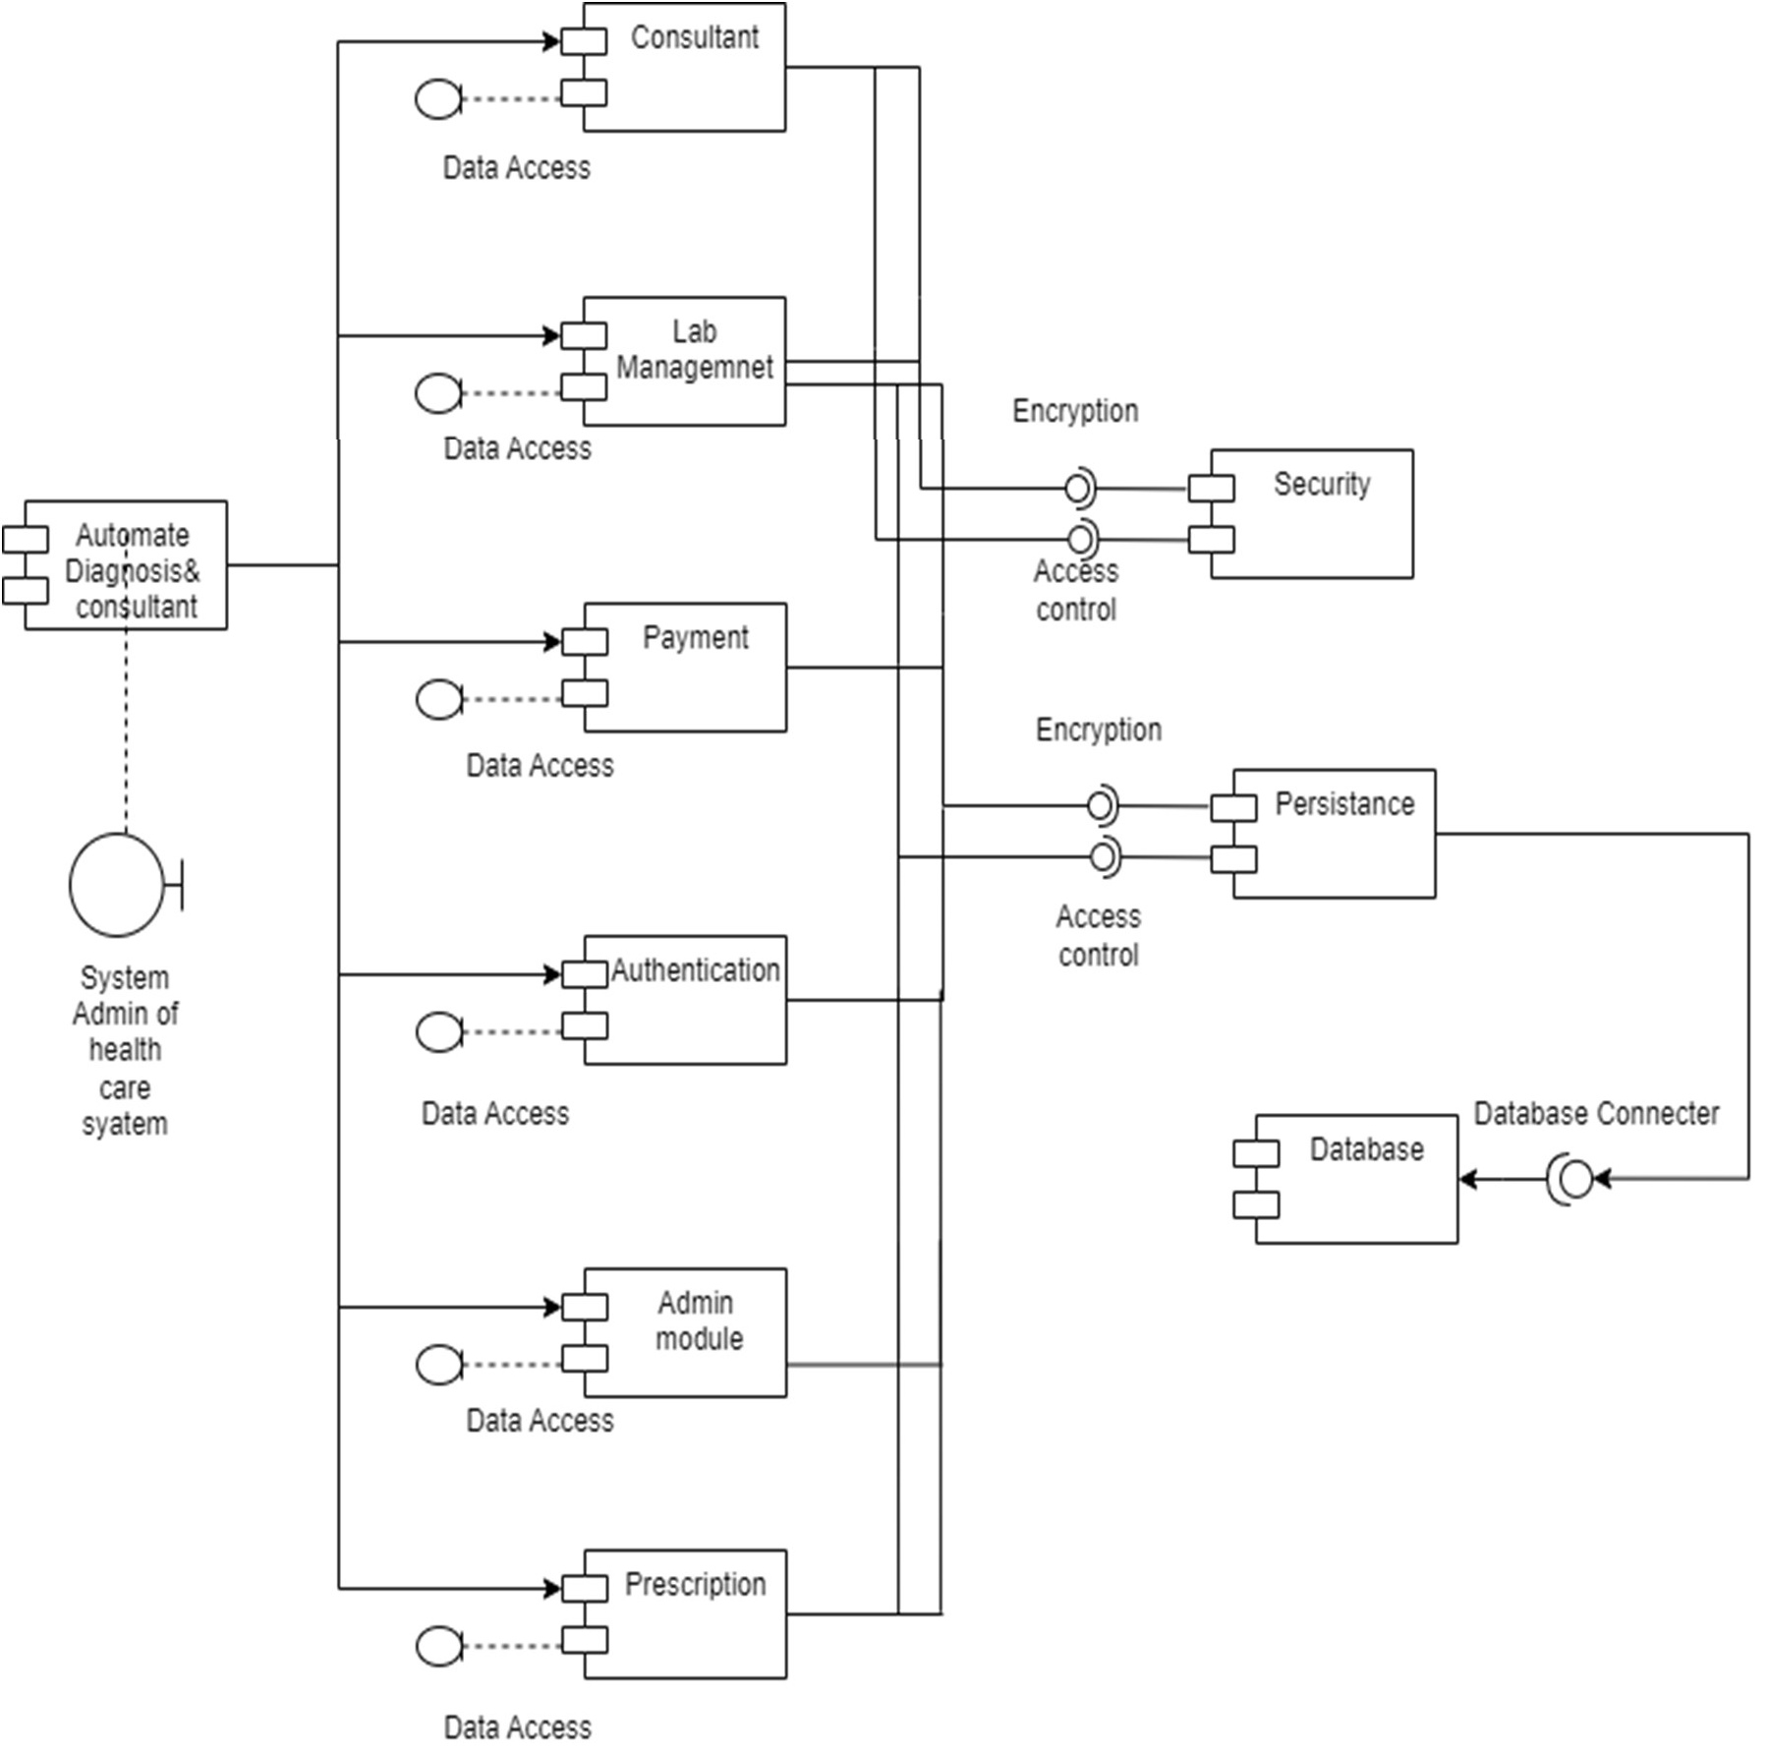

Fig 3.1: Component Diagram

The diagnostic component: This component would be responsible for analysing patient data, such as symptoms and medical history, and making a diagnosis based on that data. It may include machine learning algorithms, databases of medical knowledge, and other tools to help make accurate diagnoses. The consultation component: This component would be responsible for providing personalized recommendations to the patient based on their diagnosis. It may include resources such as treatment plans, medication recommendations, and other advice to help the patient manage their condition.

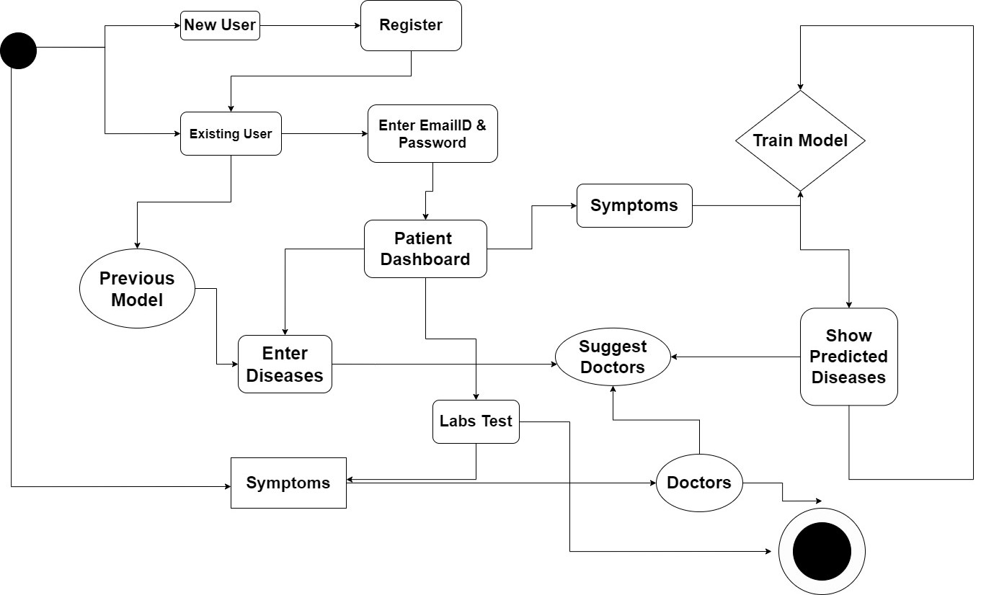

Fig 3.2: Activity Diagram (Path Labs module).

The activity diagram starts with the "Start" node, which is followed by the "Enter patient and test details" node. In this step, the user would enter information such as the patient's name, the type of test being conducted, and any other relevant details.  
The next step is "Collect sample and conduct test", which involves collecting a sample from the patient and performing the necessary lab tests. Once the test results are available, the user records them and uploads them to the system, as shown in the "Record test results and upload" node. Finally, the activity diagram ends with the "End" node, indicating that the process is complete.

Throughout the activity diagram, there may be decision points or branching paths depending on the specific requirements of the system. For example, there may be additional steps required for certain types of tests or for patients with specific medical conditions. These decision points could be represented in the activity diagram using diamond-shaped nodes with multiple outgoing arrows.

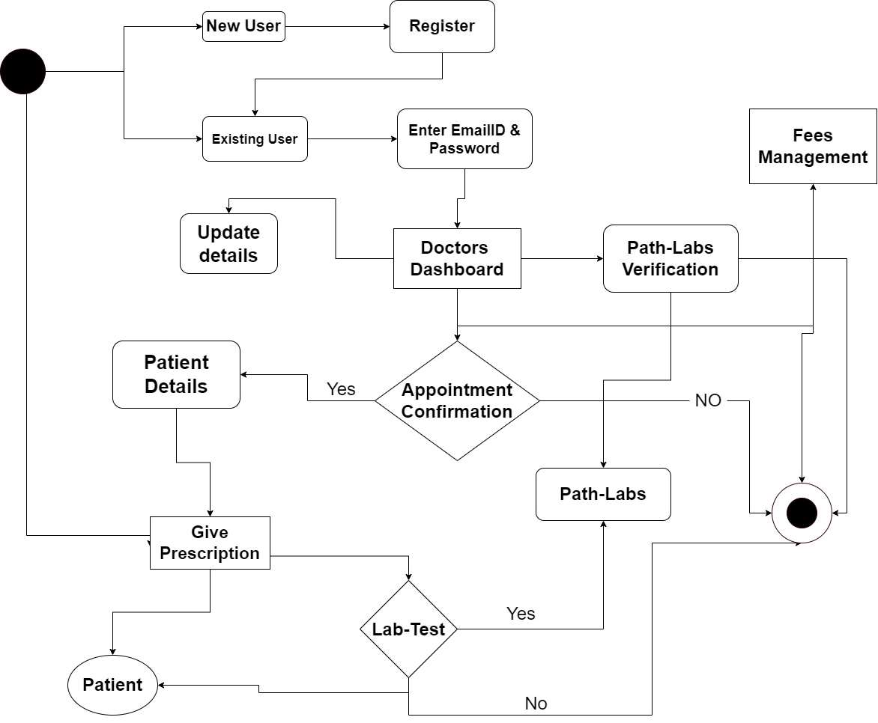

Fig 3.3: Activity Diagram (Doctors module).

The activity diagram starts with the "Start" node, which is followed by the "Retrieve patient symptoms/history" node. In this step, the doctor retrieves information about the patient's medical history, symptoms, and any other relevant information.

The next step is "Perform Diagnosis", which involves using the patient information to make a diagnosis. This step may include using machine learning algorithms, databases of medical knowledge, or other tools to help make an accurate diagnosis.

The following step is "Check for Previous Diagnoses", which involves checking the patient's medical history to see if they have any previous diagnoses or medical conditions that could impact their current diagnosis and treatment.

Once the diagnosis is complete, the doctor prescribes medication, as shown in the "Prescribe Medication" node. This step may involve selecting appropriate medications based on the patient's condition, checking for potential drug interactions, and providing instructions for taking the medication.

Finally, the activity diagram ends with the "End" node, indicating that the process is complete.

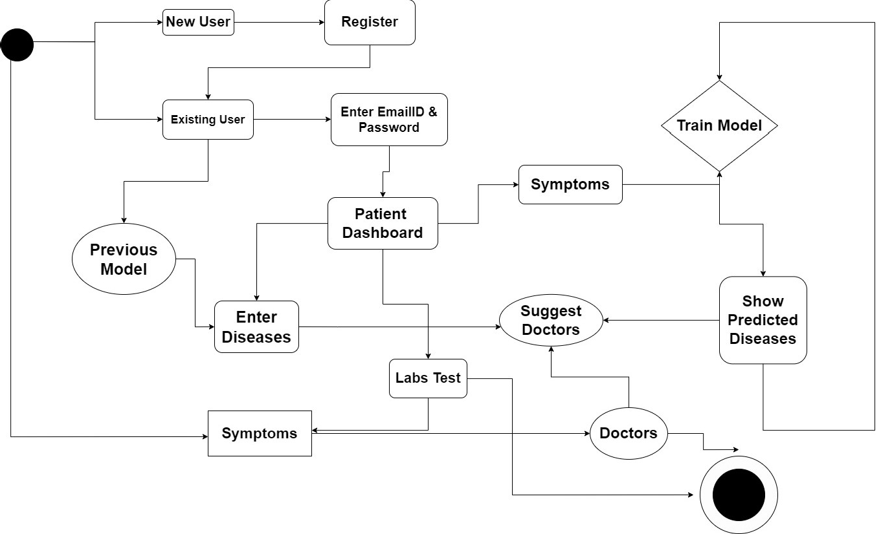

Fig 3.4: Activity Diagram (Patients module).

The activity diagram starts with the "Start" node, which is followed by the "Login to patient account" node. In this step, the patient logs in to their account in the automated diagnosis system.

The next step is "View medical history and records", which allows the patient to access their medical history and records stored in the system.

The following step is "Schedule an appointment", which allows the patient to schedule an appointment with a healthcare provider. This step may involve selecting a provider, choosing a date and time for the appointment, and providing any necessary information about the reason for the appointment.

Once the appointment is scheduled, the patient can complete a patient assessment, as shown in the "Complete patient assessment" node. This step may involve answering questions about their medical history, current symptoms, and other relevant information.

The healthcare provider uses the information provided by the patient to make a diagnosis and provide advice, as shown in the "Receive a diagnosis and advice" node.

Finally, the activity diagram ends with the "End" node, indicating that the process is complete.

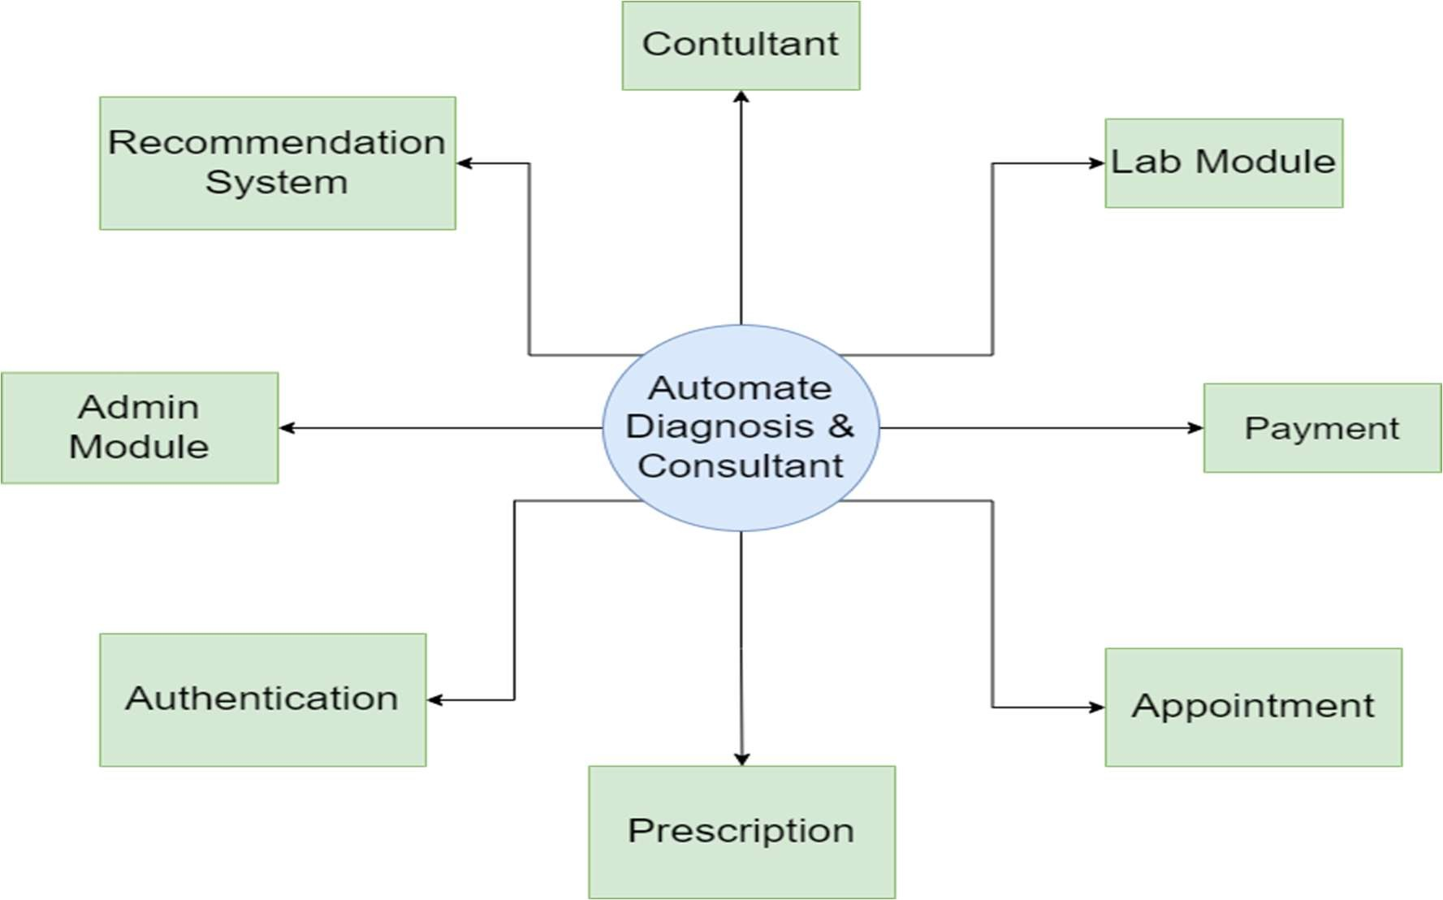

Fig 3.5: Data Flow Diagram (Level -0)

The level 0 DFD has three main components:

External Entities: These are the individuals or groups who interact with the system. In this case, the external entities are patients, healthcare providers, and lab workers. They provide input to the system and receive output from it.

System: This is the main component of the system. It includes the automated diagnosis and consultant software, as well as any hardware or other tools needed to operate the system.

Outputs: These are the results generated by the system. They include diagnoses, consultations, lab results, and medication recommendations.

The arrows in the diagram show the flow of data between the components of the system. External entities provide input to the system, which is processed by the automated diagnosis and consultant software. The output from the system is then delivered to the external entities, who use it to make healthcare decisions.

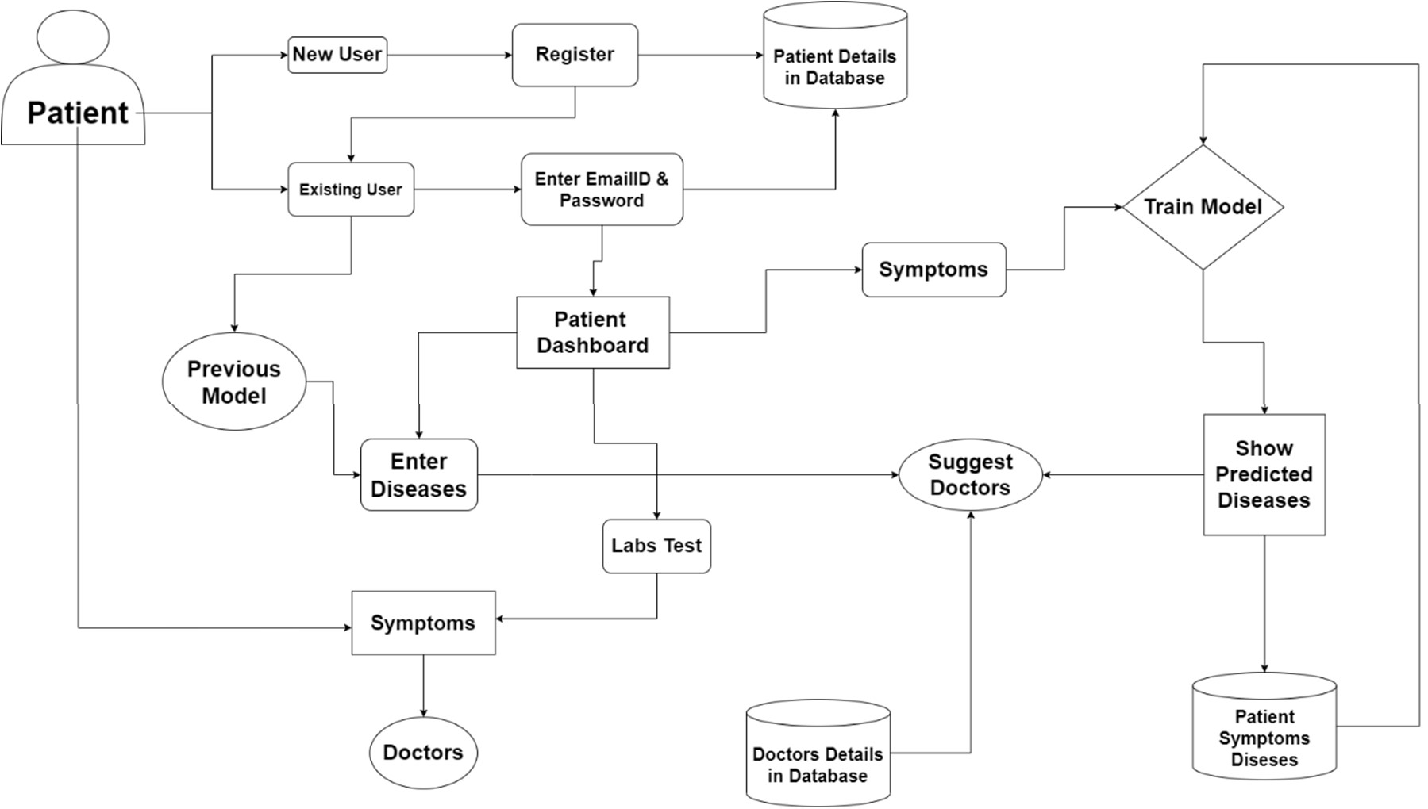

Fig 3.6: Data Flow Diagram (Level -1 Patient Module)

The Level 1 DFD of Patient Module has three main components:

External Entity: The patient, who interacts with the system.

Processes: These are the specific processes involved in the patient's interactions with the system. They include logging in to the system, viewing their medical records, scheduling an appointment with a healthcare provider, completing a patient assessment, and receiving a diagnosis.

Data Stores: The patient records database, which stores the patient's medical records and other relevant information.

The arrows in the diagram show the flow of data between the components of the system. The patient provides input to the system through various processes, and the system uses the data stores to store and retrieve information as needed.

Overall, the level 1 DFD provides a more detailed view of the patient module in the automated diagnosis and consultant system. Further levels of the DFD would break down the specific components of each process and provide more detail about the specific interactions involved.

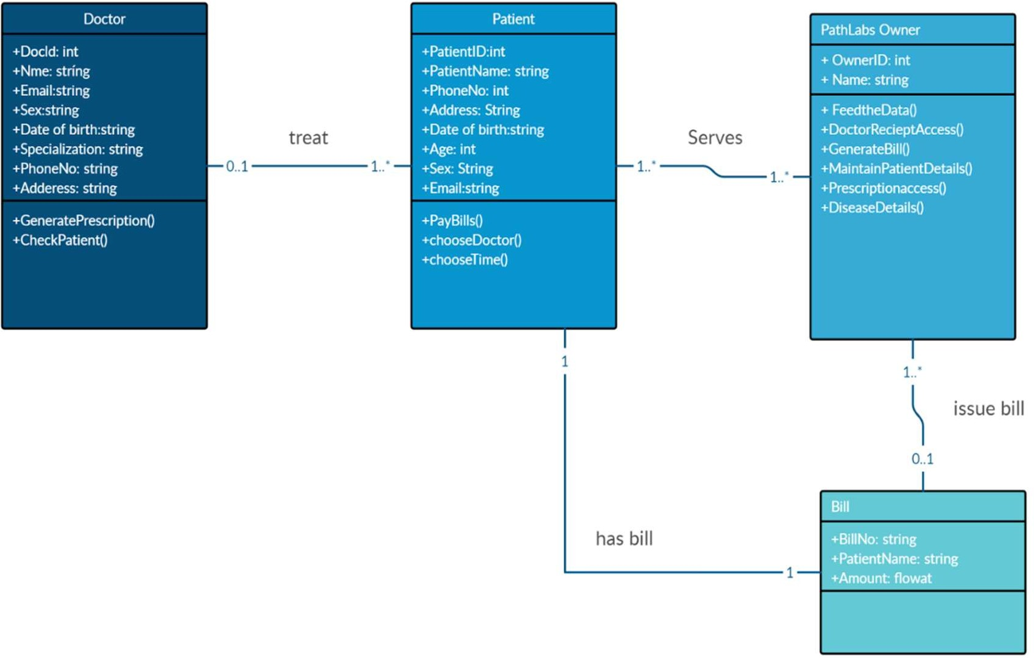

Fig 3.7: Entity Relationship Diagram

The ERD has four main entities:

Patient: Stores information about the patient, including their name, date of birth, and gender.

Visit: Represents a patient visit to a healthcare provider, and includes information about the visit date, symptoms, and associated diagnosis.

Diagnosis: Stores information about diagnoses, including the diagnosis name and description.

Healthcare Provider: Stores information about healthcare providers, including their name and specialty.

There is also an entity for Lab Results, which stores information about laboratory test results associated with a particular visit.

The arrows in the ERD show the relationships between the entities. For example, the Visit entity has a foreign key that references the Patient entity, indicating that each visit is associated with a specific patient. Similarly, the Diagnosis entity has a foreign key that references the Visit entity, indicating that each diagnosis is associated with a specific patient visit.

Overall, the ERD provides a visual representation of the relationships between the entities in the automated diagnosis and consultant system, which is useful for understanding how patient data and healthcare information are stored and managed.

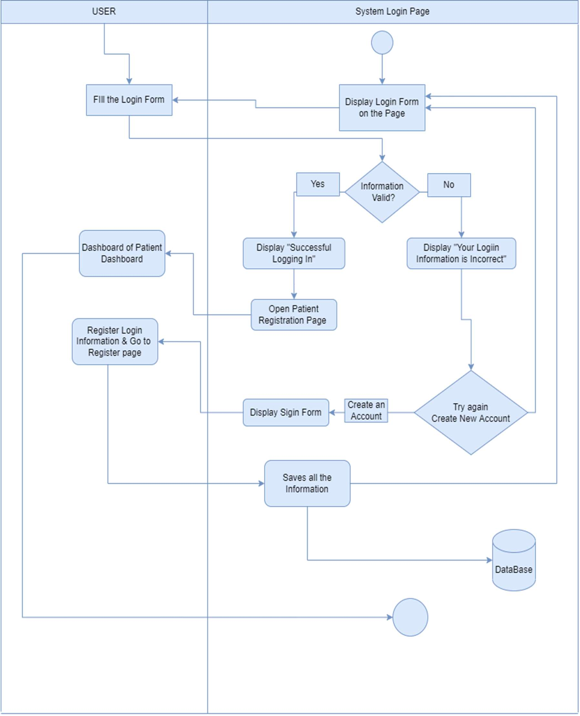

Fig 3.8: Login Module

The login module is a critical component of the automated diagnosis and consultant system, as it ensures that only authorized users are granted access to the system. To ensure the security of the system, it is important to use strong password policies, employ multi-factor authentication mechanisms, and periodically review and update user account information in the user database.

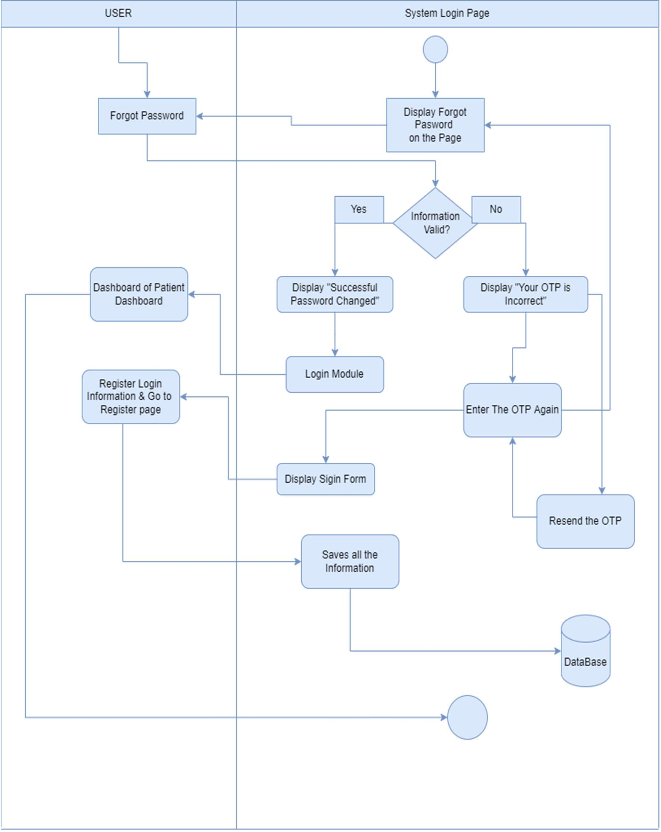

Fig 3.9: Forgot Password Module

The "Forgot password" module is an important feature of the automated diagnosis and consultant system, as it helps users recover their password in case, they forget it or if their account is compromised. To ensure the security of the system, it is important to use secure password reset links, enforce password policies, and monitor password reset activity for suspicious behavior.

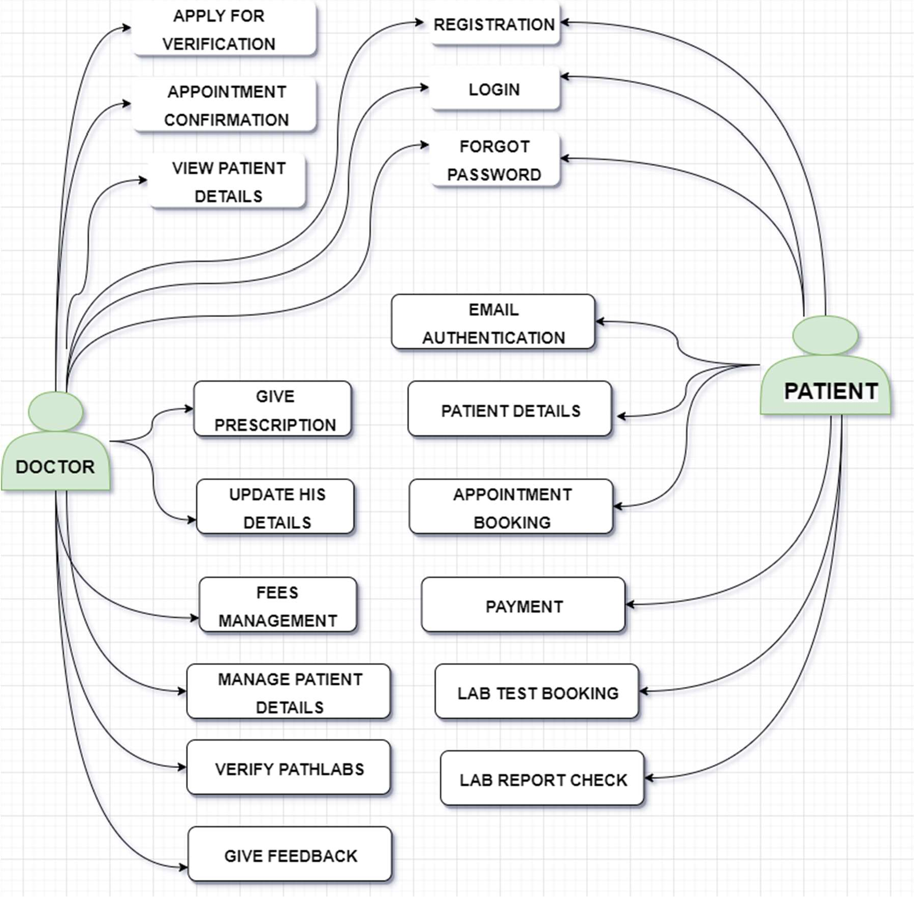

Fig 3.10: Use Case Diagram of doctor & patient Module

**In the doctor module, there are three use cases:**

View Patient: This use case allows the doctor to view the details of a patient, such as their medical history, test results, and other relevant information.

Add Diagnosis: This use case allows the doctor to add a diagnosis for a patient based on the patient's symptoms and test results.

View Reports: This use case allows the doctor to view the reports generated by the system based on the patient's diagnosis and test results.

**In the patient module, there are two use cases:**

Book Appointment: This use case allows the patient to book an appointment with a doctor based on their availability and specialty.

View Reports: This use case allows the patient to view their reports generated by the system based on their diagnosis and test results

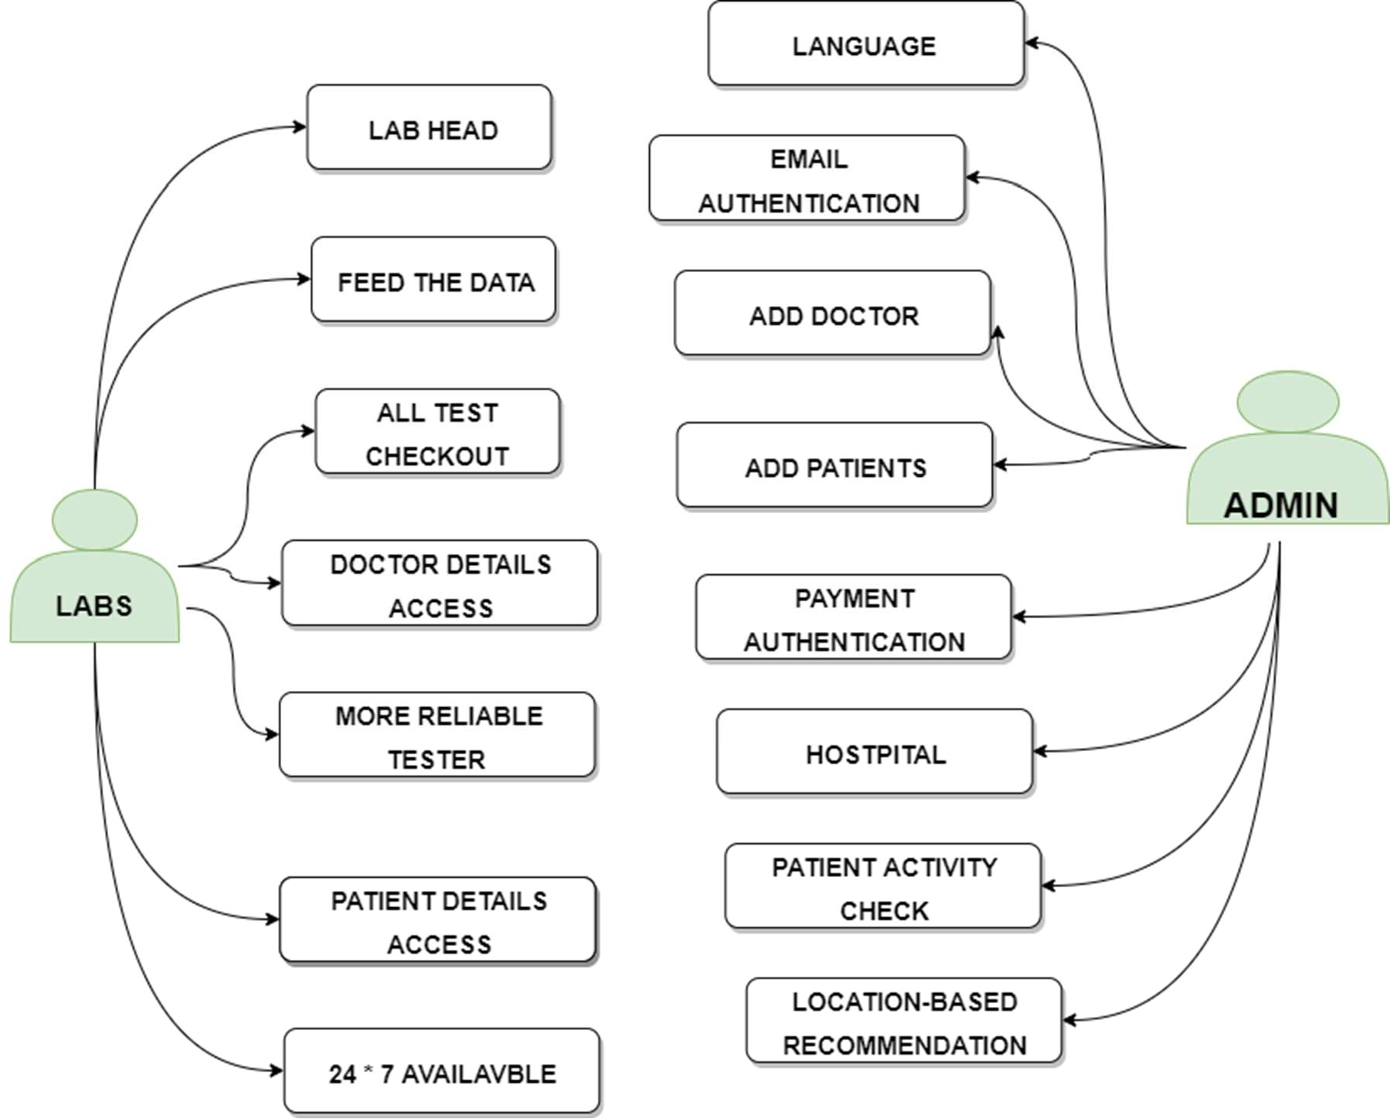

Fig 3.11: Use Case Diagram of Path labs & Admin Module

**In the admin module, there are two use cases:**

Manage Users: This use case allows the admin to manage the user accounts in the system, including creating new accounts, modifying existing accounts, and deleting accounts if necessary.

Manage Appointments: This use case allows the admin to manage the appointments scheduled in the system, including viewing, editing, and cancelling appointments.

**In the path labs module, there are two use cases:**

Upload Test Results: This use case allows the path labs to upload the test results of a patient into the system, which can be accessed by the doctor or patient.

View Test Results: This use case allows the path labs to view the test results that have been uploaded by the lab and are associated with a specific patient.

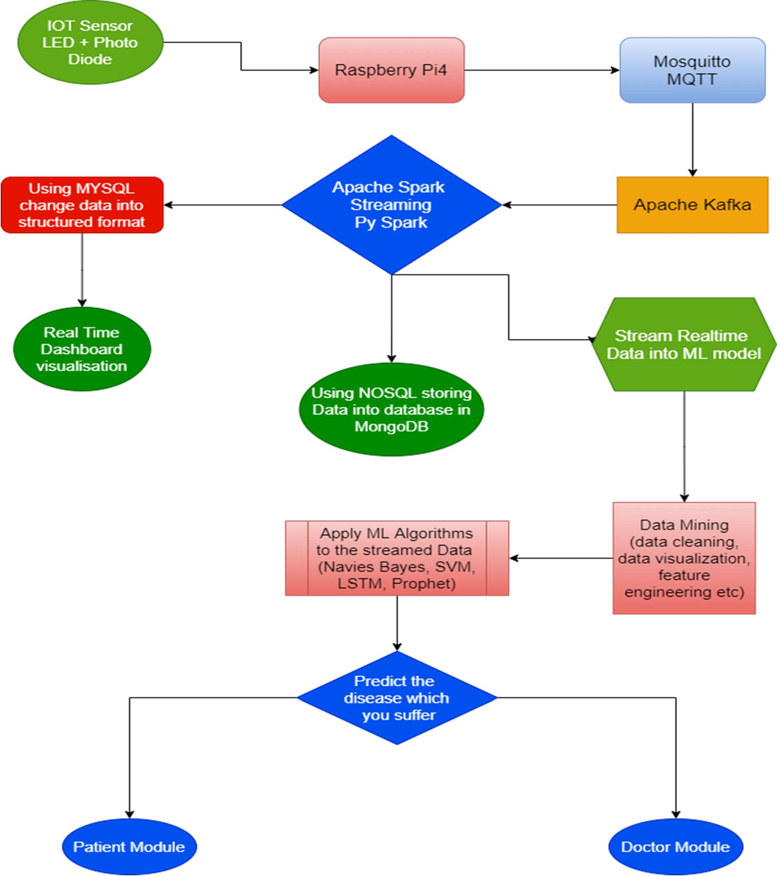

Fig 3.12: Data Streaming Model

The data streaming module of Automate diagnosis & consultant involves the real-time streaming of data from various sources to the system for analysis and processing. This module plays a critical role in the system's ability to provide quick and accurate diagnoses and recommendations. Here are some of the key components and processes involved in the data streaming module:

Data Sources: The data streaming module must be able to receive data from various sources, including medical devices, electronic health records, wearables, and other sources. These sources may provide data in different formats and require different protocols for communication.

Data Preprocessing: Once the data is received, it must be preprocessed to ensure that it is in the correct format for analysis. This may involve cleaning the data, removing duplicates, and ensuring that the data is consistent across different sources.

Data Integration: The data streaming module must be able to integrate data from multiple sources to provide a complete picture of the patient's health status. This may involve merging data from different devices or systems and ensuring that the data is synchronized and up-to-date.

Real-Time Streaming: The data streaming module must be able to receive data in real time and process it quickly to provide immediate insights and recommendations. This requires the use of streaming technologies such as Apache Kafka, Apache Flink, or AWS Kinesis.

Data Analysis: Once the data is received and preprocessed, it must be analyzed using machine learning algorithms to provide accurate diagnoses and recommendations. This may involve training machine learning models on large datasets to improve the accuracy of the analysis.

Visualization and Reporting: The results of the data analysis must be presented to healthcare professionals and patients in a way that is easy to understand. This may involve creating visualizations and reports that highlight key insights and trends.

Overall, the data streaming module is essential to the success of Automate Diagnosis & Consultant, as it enables the system to process and analyze large amounts of data in real-time to provide accurate diagnoses and recommendations.

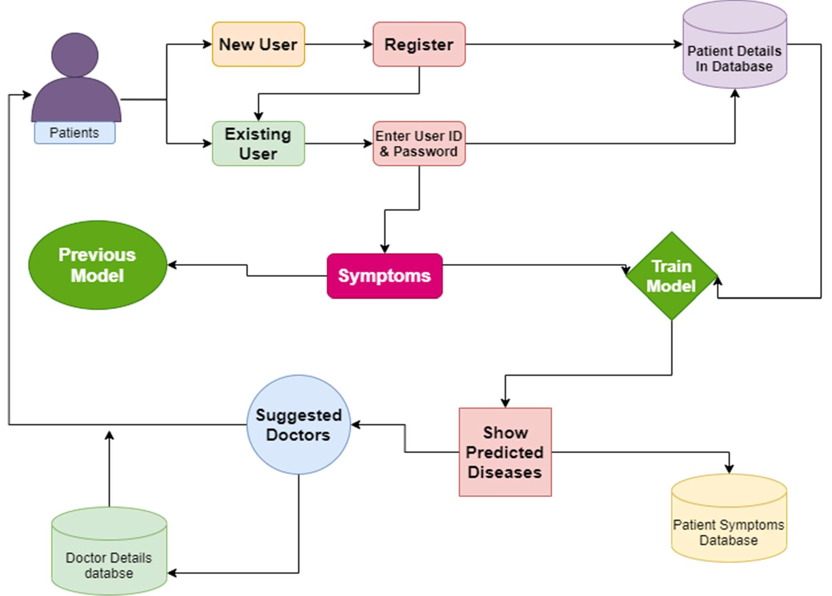

Fig 3.13: Use case model of the Frontend link with ML model.

The use case model shows the different use cases or functionalities that are available when the frontend is linked with an ML model.

Upload Image: This use case allows the user to upload an image of a medical scan or test for analysis.

Preprocess Image: This use case involves preprocessing the image to prepare it for analysis by the ML model. This may involve resizing, normalization, or other techniques.

Predict Disease: This use case involves using the ML model to analyze the preprocessed image and predict the presence of a particular disease or condition.

View Prediction Result: This use case allows the user to view the prediction result generated by the ML model, such as a diagnosis or probability of a specific disease.

These use cases are essential for the front end with an ML model to function properly and provide the necessary services to the users.

## CHAPTER 4

## IMPLEMENTATION

The methodology's goal is to forecast an individual's risk of developing kidney, lung, and breast cancer, heart disease, and diabetes using a few questions and machine learning models in an end-to-end procedure. the system I used for my research has the following software and system configurations: On an Intel(R) Core(TM) i5-2310M GPU @1650Ti with 8 GB RAM, Jupyter Notebook 5.5.0 and VS Code 1.73 are used to implement Python 3 and the Flask framework.

Figure 4.1 displays a block schematic of the fundamental procedures used for each machine-learning model. To transform the raw data into a form that can be used, data cleaning is done first. Data analysis is carried out after data cleansing to ascertain the significance of characteristics. Once a goal has been established, it is time to start gathering the data required for analysis. Your data team will be responsible for cleaning and sifting through the data once it has been gathered from all the required sources. Because not all data is good data, data cleansing is crucial during the data analysis process. Data mining, which is referred to as "knowledge discovery inside databases," is one method. In order to predict what will probably happen next in the future, the predictive analysis looks ahead to the future. These methods are a component of inferential statistics, which is the act of examining statistical data in order to make inferences about the connections between various sets of data. We have to utilize the Train/Test methodology to evaluate the model's performance. The train/test approach is a way to gauge how accurate your model is. Because you divide the data set into two sets, a training set and a testing set, the method is known as Train/Test. 20% for testing, 80% for training. Using the training set, you train the model.

Data mining is a technique used to discover patterns and extract knowledge from large datasets. It involves analyzing data to uncover hidden relationships, trends, and insights that can be used for various purposes, including prediction. Predictive analysis is a subset of data mining that focuses on predicting future outcomes based on historical data. By analyzing patterns and trends in the data, predictive models can be developed to forecast what is likely to happen next. These models utilize statistical techniques and algorithms to make these predictions. Inferential statistics is the branch of statistics that deals with drawing conclusions or making inferences about a population based on a sample of data. It involves examining the relationships between different sets of data and using statistical methods to make predictions or generalizations.

The Train/Test methodology is a common approach used to evaluate the performance of predictive models. This methodology involves dividing the dataset into two subsets: a training set and a testing set. Typically, around 80% of the data is allocated for training, and the remaining 20% is used for testing. The training set is used to train the predictive model. The model learns from the patterns and relationships in the training data to make predictions. Various algorithms and techniques can be applied to train the model, depending on the specific problem and data characteristics. Once the model is trained, it is then tested using the testing set. The testing set contains data that the model has not seen before. The model's predictions on the testing set are compared to the actual values to evaluate its accuracy and performance. This evaluation helps assess how well the model generalizes to unseen data and provides an indication of its predictive capabilities. After confirming that the model performs well on the testing set, it can be used to make predictions on new, unseen data. These predictions can be valuable for making informed decisions, optimizing processes, or identifying potential risks or opportunities. In summary, data mining and predictive analysis involve using statistical techniques and algorithms to uncover patterns and make predictions based on historical data.

Integration of clinical decision support with computer-based patient records could reduce medical errors, enhance patient safety, decease unwanted practice variation and improve practice outcome which can help significantly improve the quality of clinical decisions using the data mining modelling technique & Integrate doctors and patients via interacting and user- friendly interface so that Patient can easily utilize in emergency situations. There are three primary goals of this model tend to be prediction, description, and presentation.

The integration of clinical decision support with computer-based patient records is a powerful approach that can have several benefits in healthcare. This integration involves combining the functionalities of clinical decision support systems (CDSS) with electronic health records (EHR) to improve patient care.

One of the primary goals of this model is prediction. By leveraging data mining modeling techniques, the system can analyze patient data, such as medical history, laboratory results, and demographic information, to predict potential health outcomes or risks. For example, the system can identify patients who are at high risk of developing a particular condition or those who may benefit from a specific treatment approach. These predictions can help healthcare providers make informed decisions and take preventive measures to improve patient outcomes.

The second goal is the description. By utilizing data mining techniques, the system can extract valuable insights and patterns from large amounts of patient data. This can include identifying trends, correlations, and associations that may not be immediately apparent to healthcare providers. For instance, the system can analyze patterns in patient responses to different treatments or identify factors that contribute to adverse events. These descriptions can provide a deeper understanding of patient conditions and inform clinical decision-making.

The third goal is presentation. To ensure effective utilization of the integrated system, it is crucial to present the information in a user-friendly and interactive manner. The system should provide a seamless interface for doctors and other healthcare professionals to access patient data, CDSS recommendations, and relevant clinical guidelines. Additionally, the system can empower patients to access their own health information, interact with the CDSS, and make informed decisions about their care, especially in emergency situations.

By achieving these goals, the integration of clinical decision support with computer-based patient records can have several benefits. It can help reduce medical errors by providing evidence-based recommendations to healthcare providers, enhancing patient safety. It can also decrease unwanted practice variation by promoting standardized care protocols based on best practices. Moreover, it can improve practice outcomes by enabling healthcare providers to make more accurate diagnoses, choose appropriate treatments, and monitor patient progress effectively. Overall, this model aims to improve the quality of clinical decisions by leveraging data mining techniques to predict health outcomes, describe patient conditions, and present relevant information to healthcare providers and patients in an accessible and user-friendly manner.

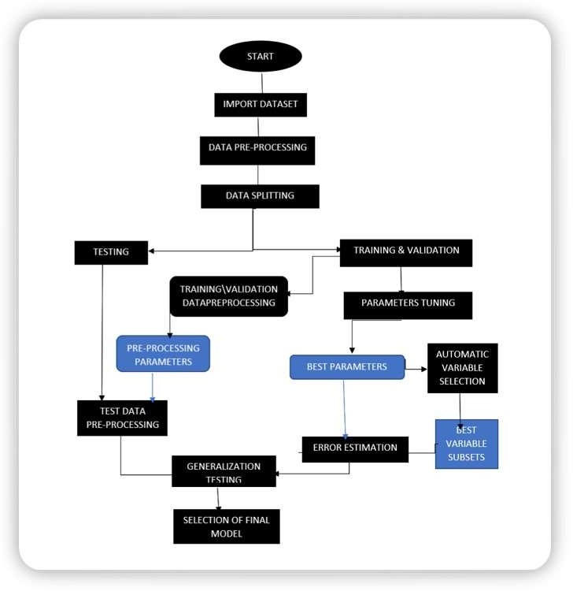

Fig 4.1: Machine Learning Algorithm’s flow chart

## 4.1 Algorithm for the proposed system:

##### Random Forest Classifier Algorithm:

A group of several decision trees is called a random forest. Decision trees are employed as parallel estimators in the bagging technique, which is used to construct random forests. When used in a classification issue, the outcome is determined by the majority vote of the findings from each decision tree. In a regression, the mean value of something like the target values in a leaf node serves as the prediction. The mean value of the decision tree outcomes is considered by random forest regression. Train the Random Forest Classifier model using the training dataset. The algorithm creates an ensemble of decision trees, where each tree is trained on a different subset of the training data and features. The decision trees are built using a random selection of features at each node to maximize diversity and reduce overfitting. Fine-tune the hyperparameters of the Random Forest Classifier model to optimize its performance. This may include adjusting the number of trees in the forest, the maximum depth of each tree, and the number of features considered at each split. Evaluate the trained model using the test dataset. Calculate metrics such as accuracy, precision, recall, and F1-score to assess the performance of the Random Forest Classifier in predicting diseases.

##### Logistic Regression:

A set of independent variables is used to estimate discrete values (often binary values like 0/1) using logistic regression. By fitting data to a logit function, it aids in the prediction of an event's likelihood. Logistic regression is another name for it. The following techniques are frequently used to enhance logistic regression models: incorporate interaction terms, remove features, regularize approaches, and employ a non-linear mode.

##### Decision Tree:

The Decision Tree method, a supervised learning technique used for issue classification, is one of the most widely used algorithms in machine learning today. Both continuous and categorical dependent variables may be classified using it. Based on the most important characteristics/independent variables, this method splits the population into two or more homogenous groupings.

**Step 1**: Gathering and identifying the data that will be provided to the network as input is the first stage in the categorization of diabetes or heart disease using Logistic Regression, Decision Tree & Random Forest. Collect relevant data related to diseases, including symptoms, medical history, test results, and patient demographics. Preprocess the data by handling missing values, encoding categorical variables, and normalizing numerical features.

**Step 2**: The network receives a defined training dataset and the selected training method. After the training phase, the Logistic Regression, Decision Tree & Random Forest are also put to the test to get feedback on how well they categorize the condition. Train the Decision Tree model using the training dataset. The algorithm recursively splits the data based on the features to create a tree-like structure. At each node, the algorithm selects the feature that best separates the data based on a specific criterion (e.g., Gini impurity or information gain). This process continues until a stopping criterion is met, such as reaching a maximum depth or a minimum number of samples per leaf.

|  |  |  |  |  |
| --- | --- | --- | --- | --- |
| **Category** | **Algorithm** | | **Function** | **Use** |
| Basic Regression | | Logistic Regression | linear_model.LogisticRegression() | The target variable is categorical. |
| Classification | | Decision Tree | tree.DecisionTreeClassifier() | If/then/else. Non-contiguous data. can also be regression. |
| Classification | | Random Forest | ensemble.RandomForestClassifier() | Find the best split randomly. can also be regression. |

Table 4.1

**Step 3:** The "training data set" is used to train the classifier, the "validation set" is used to fine-tune the parameters, and the "test data set" is used to evaluate the performance of the classifier. It's vital to keep in mind that only the training and/or validation set is available when the classifier is being trained. The test data set must not be used for classifier training. Only when the classifier is being tested will the test set be accessible? Fine-tune the hyperparameters of the Decision Tree model to optimize its performance. This may include adjusting the maximum depth of the tree, the minimum number of samples required to split a node, or the criterion used to measure the quality of a split.

**Step 4:** We may then create a confusion matrix, which indicates how effectively our model has been trained after this is complete. True Positives, True Negatives, False Positives, and False Negatives are the four parameters that make up a confusion matrix. In order to create a model that is more accurate, we would want to obtain more data for the true negatives and true positives. The number of classes has a direct impact on the size of the confusion matrix. Once the model is trained and evaluated, it can be used to make predictions on new, unseen data. Provide the necessary input, such as symptoms or patient information, to the trained model, and it will traverse the decision tree to output the predicted disease.

**Step 5:** The model creation process includes a step called model evaluation. Finding the model that best depicts our data and predicts how well the model will perform in the future is helpful. To enhance the model, we may adjust its hyper-parameters to attempt to raise its accuracy while also looking at the confusion matrix to try to increase the proportion of true positives and true negatives. It is important to note that implementing the Decision Tree algorithm for disease prediction requires a well-prepared and representative dataset, appropriate preprocessing techniques, careful hyperparameter tuning, and thorough evaluation to ensure reliable and accurate predictions. Decision Trees can be effective for diseases prediction, especially when there are clear decision boundaries and interpretable rules. However, they may not capture complex relationships as effectively as other algorithms like Random Forests or Gradient Boosting.

Anaconda is a popular distribution of Python and R programming languages that is widely used in data science and machine learning. It provides a comprehensive package management system, including various libraries and tools required for scientific computing and data analysis. Jupyter Notebook is an open-source web application that allows you to create and share documents containing live code, visualizations, and narrative text. Exploratory Data Analysis is a crucial step in understanding and analyzing a dataset. It involves visually exploring the data, examining its characteristics, identifying patterns, and detecting anomalies. NumPy is a fundamental library for scientific computing in Python. It provides support for efficient numerical operations, multi-dimensional arrays, and a wide range of mathematical functions. Pandas is a powerful data manipulation and analysis library for Python. It offers data structures, such as Data Frames and Series, that enable easy handling of structured data. Matplotlib is a popular data visualization library in Python. It provides a wide range of plotting functions and customization options to create insightful visualizations. Scikit-learn is a comprehensive machine-learning library in Python. It offers a wide range of tools and algorithms for tasks such as classification, regression, clustering, and dimensionality reduction.

Machine Learning & Deep Learning Algorithms are the core components of a disease prediction system. ML algorithms, such as decision trees, random forests, support vector machines, and logistic regression, can be used for traditional machine learning-based disease prediction. DL algorithms, such as neural networks, can be employed for more complex tasks, leveraging deep learning architectures to extract intricate patterns from data. By leveraging these technologies, you can preprocess and analyze medical datasets, develop disease prediction models, visualize data patterns, and evaluate model performance. The combination of Anaconda, Jupyter Notebook, EDA, NumPy, Pandas, Matplotlib, Scikit-learn, and ML/DL algorithms provides a robust toolkit for building disease prediction systems that can assist in diagnosing and predicting diseases based on patient data.

## 4.2 Proposed System of Automate Diagnosis & Consultant:

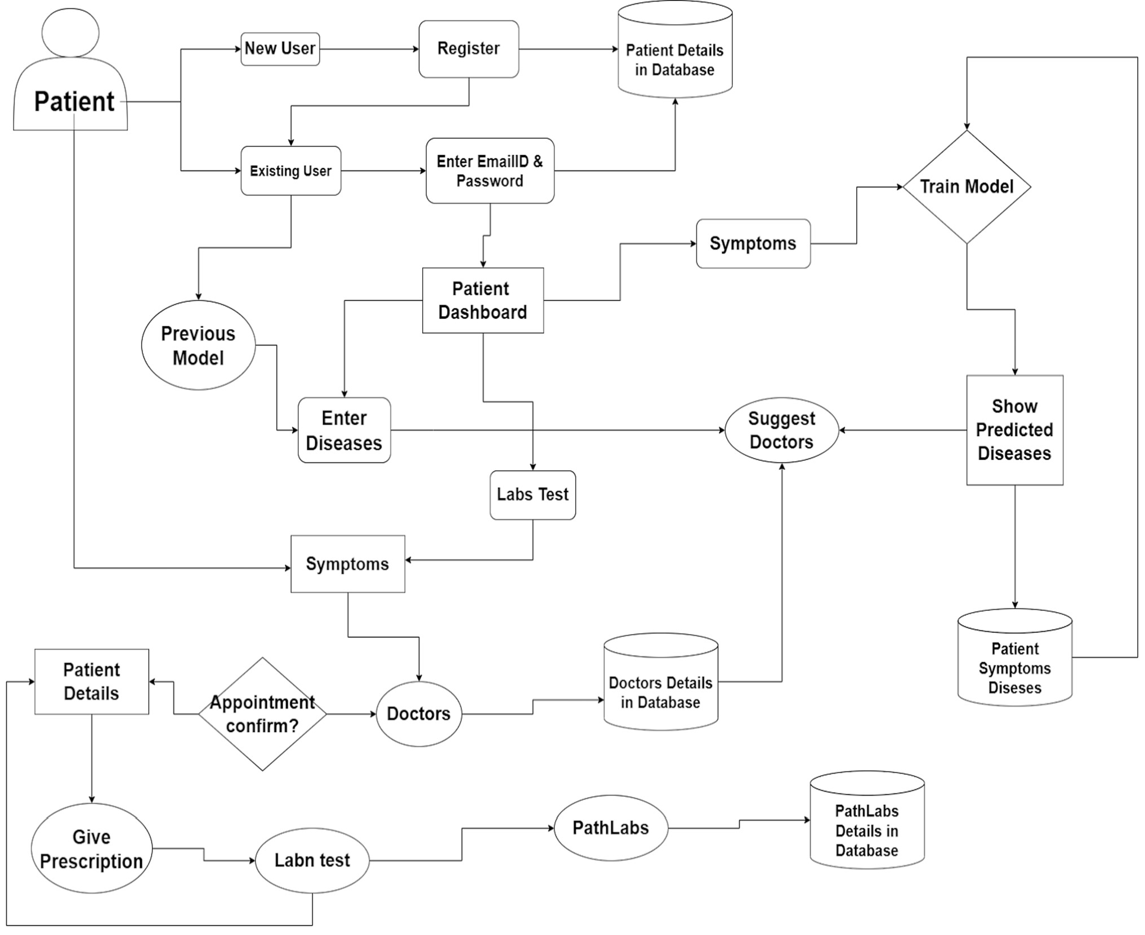

Fig 4.2: System flow Diagram

The dashboard will run the function that connects patients and doctors. The dashboard has been designed to get a better understanding of a patient's condition. The medical profession is being transformed by technological advancements, which is causing a rapid change in the medical business. Artificial intelligence (AI) is being used to diagnose illnesses, predict diseases, and develop treatments. In this article, it will be discussed how AI can support the management of level-three 911 calls and assist physicians in making better patient decisions. According to the doctors' available time slots, those who have appointments can show up for their appointments. To avoid any unneeded waiting times, this is done. Modern medical professionals are employing cutting-edge technology to provide more precise diagnoses and individualized treatment strategies. Doctors can now give patients extensive medical data, an in-depth report on their symptoms, and personalized care plans that can be seen on a mobile device thanks to artificial intelligence (AI). With the use of an app, the doctor may view the patient's information, write him a prescription, and suggest testing. This software assists in quickly diagnosing the patient since it has all the information required to understand the ailment, its symptoms, and recommended treatments. The outdated paper lab slip is being replaced with a modern dashboard. Patients will be able to schedule an appointment at a time that works for them because these slips are now digital. As soon as the reports are finished being processed by the laboratory, they will also be automatically uploaded into the patient's database. Doctors use information from a variety of sources to provide the most precise diagnosis possible. With the more recent use of electronic medical records, a more complete image of patients is now possible, improving care.

Automate Diagnosis & Consultant is a web-based platform that offers blockchain-based medical record storage. Its primary goal is to prioritize individuals' health by providing a secure repository for storing medical records and facilitating access to the right users when necessary. The platform recognizes the significance of health and aims to ensure that it doesn't take a back seat to other priorities. It emphasizes the importance of maintaining good health and offers resources and guidance to help individuals regain their health and learn how to stay healthy. Automate Diagnosis & Consultant leverages blockchain technology, specifically the Ethereum Blockchain, to establish a secure and transparent system for storing medical records.

By utilizing blockchain, which is known for its immutability and decentralized nature, Automate Diagnosis & Consultant aims to enhance data security, privacy, and accessibility.

The platform allows users to securely store their medical records on the Ethereum Blockchain. This ensures that the records are tamper-proof and resistant to unauthorized modifications.

Additionally, by leveraging blockchain's distributed ledger technology, Automate Diagnosis & Consultant facilitates seamless and controlled access to medical records, ensuring that only authorized users can retrieve the information. By offering a secure and blockchain-based medical record storage solution, Automate Diagnosis & Consultant aims to streamline access to medical information, enhance data security, and empower individuals to take control of their health.

**Ethereum Blockchain Integration:**

* Integrates with the Ethereum blockchain network to leverage its features for storing and managing medical records.
* Utilizes smart contracts to define the logic for accessing and updating medical records.
* Implements a decentralized consensus mechanism (e.g., Proof of Work, Proof of Stake) to ensure the integrity and immutability of stored records.

**Medical Record Storage and Encryption:**

* Implements secure storage mechanisms to protect sensitive medical data.
* Utilizes encryption techniques to secure the confidentiality of medical records stored on the blockchain.
* Adheres to privacy regulations (e.g., HIPAA) to ensure compliance and protect patient information.

**Interoperability and Data Exchange:**

* Supports interoperability standards (e.g., HL7 FHIR) to facilitate seamless data exchange with other healthcare systems.
* Enables integration with external healthcare providers' systems to access additional medical data.
* Ensures proper data mapping and transformation to maintain data integrity during the exchange.

**Audit Trail and Transparency:**

* Maintains an immutable audit trail of all interactions with medical records, including access, modifications, and sharing.
* Provides transparency and traceability of record access and updates, enhancing accountability and security.

##### Scalability:

* + - * The primary objective of a SWOT analysis is to help organizations develop a full awareness of all the factors involved in making a business decision.
      * Strength: Small (4-5 employees) can change and adapt quickly & gives a unique advantage.
      * Weakness: Team members who are not much trained in both technical and professional engineering. No one has been through any such type of technical training program.
      * Opportunity: Market trends & Economic trends will take us to new heights.
      * Threats: Political, environmental, economic regulations & Funding part is our main threats.

##### How Realistic to Achieve/Make?

* + - * It can be easily implementable because in this pandemic period, most people are technically advanced & they are mostly relying on the Internet.
      * It can be widely spread on different social media platforms, Application based platforms like google play store, Appstore, etc.
      * It can be easily accessed & modified.

##### Any Threat/Risk/Problem that you can foresee?

Bad Design, Poor user Experience, Slopy implementation, feature creep, & lack of quality control all contribute to product failure.

## 4.3 Implementation activity:

Disease diagnosis using Machine Learning & Deep Learning Models

* + - This project focused on many health issues from which not only India but the whole World is suffering. Visualize the dataset & using All ML & DL algorithms to diagnose Diseases.
    - Dataset used: Kaggle Cardiovascular, diabetes, Kidney, Breast Cancer, malaria etc. dataset
    - Project GitHub Link: https://github.com/ankiii07/Automate-Diagnosis

##### Economic Sustainability:

* + - We first go personally to many hospitals for our product launching & later to some remote areas so that they use our application & get more & more benefits from it from anywhere.
    - At the Initial Stage we just put more & more effort to setup up in the market not on generating revenue.
    - It is not for generating revenue but later after this product gets popular and provide more & more benefits to people, then we take charges for using this application which is affordable to our middle-order people.

##### Environment Sustainability:

* The idea is much innovative and not implemented with such mixed technology so for which made the people to their comfortable and so guide them to reach their desire.
* Apart from this it is an initiative that has not been seen so far and it has Less development and maintenance cost and high-profit values.
* This Project is Environment Sustainable & much helpful to Remote areas public, rural area public & it does not cause any environmental damage.

## Technology Used

* **Web Development**
  + - **Frontend**: HTML, CSS, JavaScript.
    - **Backend**: NodeJs, ExpressJs MongoDB.
* **Machine Learning & Deep Learning**
* Anaconda, Jupyter Notebook, EDA, Data Collection, Cleaning, Visualisation, NumPy,

Pandas, Seaborn, SciPy, Matplotlib, Pandas, Sklearn Libraries, ML Algorithms

* **Augmented Reality**
* Unity, Vuforia SDK, AR Core, A-Frame, JDK, Augmented Reality integrated with Machine Learning
* **Blockchain**
  + MetaMask, Web3.Js.

**CHAPTER 5**

**RESULTS AND DISCUSSIONS**

**5.1 User Interface Representation**

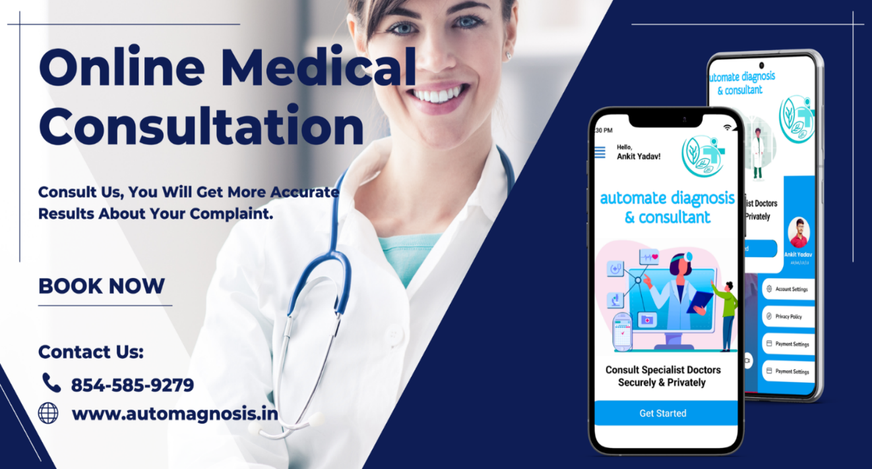

Fig 5.1: User Interface of project

Online medical consultations can be convenient for patients who are unable to visit a healthcare provider in person due to geographical or mobility constraints. However, it's important to note that online consultations may not be suitable for all medical issues, and in some cases, an in-person examination may be necessary to properly diagnose and treat a condition.

**5.2 Snapshots of Disease Prediction Module with brief detail of each**

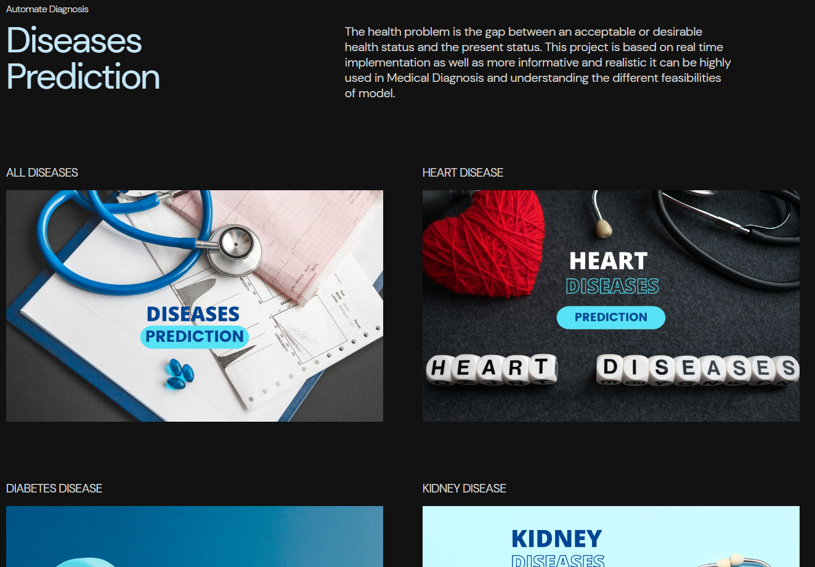

Fig 5.2: Disease Prediction Modules

Disease prediction in automated diagnosis involves using machine learning algorithms and other artificial intelligence (AI) techniques to analyze medical data and predict the likelihood of a patient having a particular disease or condition.

The process of disease prediction typically involves collecting and analyzing various types of patient data, including medical history, symptoms, test results, and other relevant information. This data is then fed into a machine learning algorithm or AI system, which uses statistical models and other techniques to analyze the data and make predictions about the patient's health.

Improved accuracy: Machine learning algorithms can analyze large amounts of medical data and identify patterns that may not be easily identifiable by humans, resulting in more accurate predictions.

Faster diagnosis: Automated diagnosis systems can analyze medical data quickly, allowing healthcare providers to diagnose and treat patients more quickly.

Reduced healthcare costs: Automated diagnosis can reduce the need for expensive diagnostic tests and procedures, resulting in lower healthcare costs.

**5.3 Snapshots of 4 Main Modules of Automate Diagnosis & Consultant with a brief detail of each**

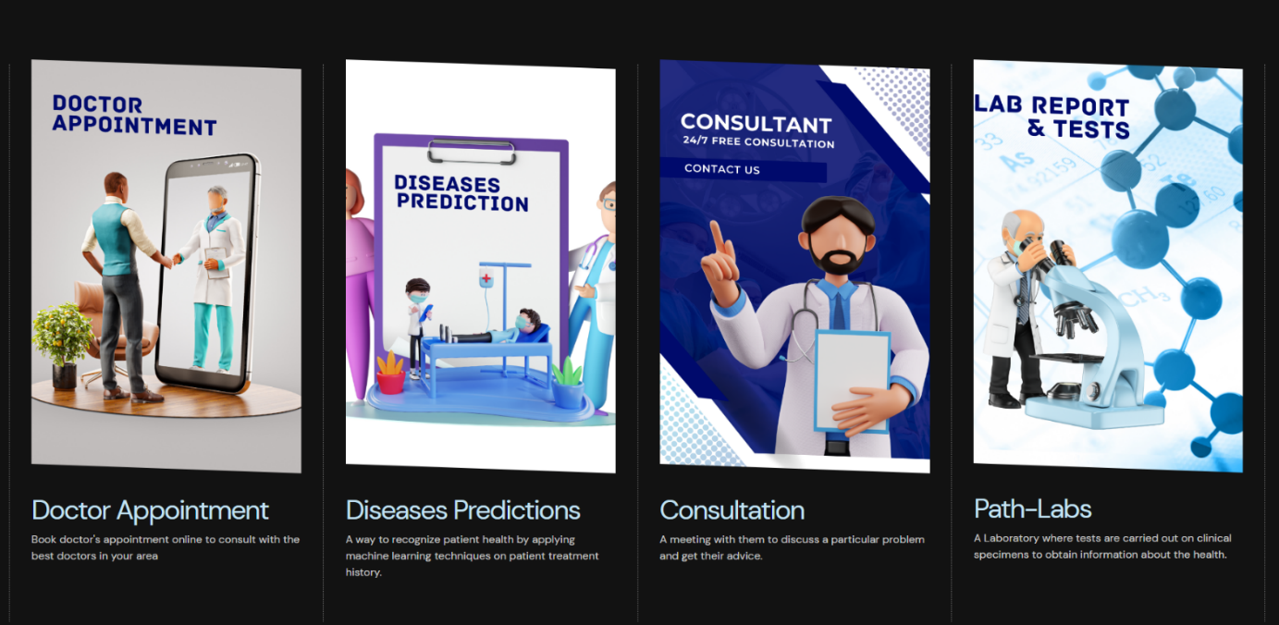

Fig 5.3: Various modules of project

**Doctor Appointment:** The Doctor Appointment module allows patients to schedule appointments with doctors online. Patients can view the availability of doctors, book appointments, and receive reminders about upcoming appointments. This module helps to streamline the appointment booking process, reducing wait times, and improving patient satisfaction.

**Disease Prediction:** The Disease Prediction module uses machine learning algorithms to analyze medical data and predict the likelihood of a patient having a particular disease or condition. The module can analyze various types of data, including medical history, symptoms, and test results, to provide accurate and fast predictions. Disease prediction can help doctors to diagnose diseases early and accurately, resulting in better treatment outcomes.

**Consultation:** The Consultation module allows patients to consult with doctors remotely using video conferencing, phone calls, or chat platforms. This module enables patients to receive medical advice and treatment from the comfort of their homes, making healthcare more accessible and convenient. The consultation module is particularly useful for patients who live in remote or rural areas, as well as those who have mobility issues.

**Path Labs:** The Path Labs module allows patients to access laboratory services online. Patients can schedule appointments for lab tests, receive test results online, and consult with doctors about their test results. This module can help to reduce the time and cost associated with laboratory testing, and enable patients to receive faster and more accurate diagnoses.

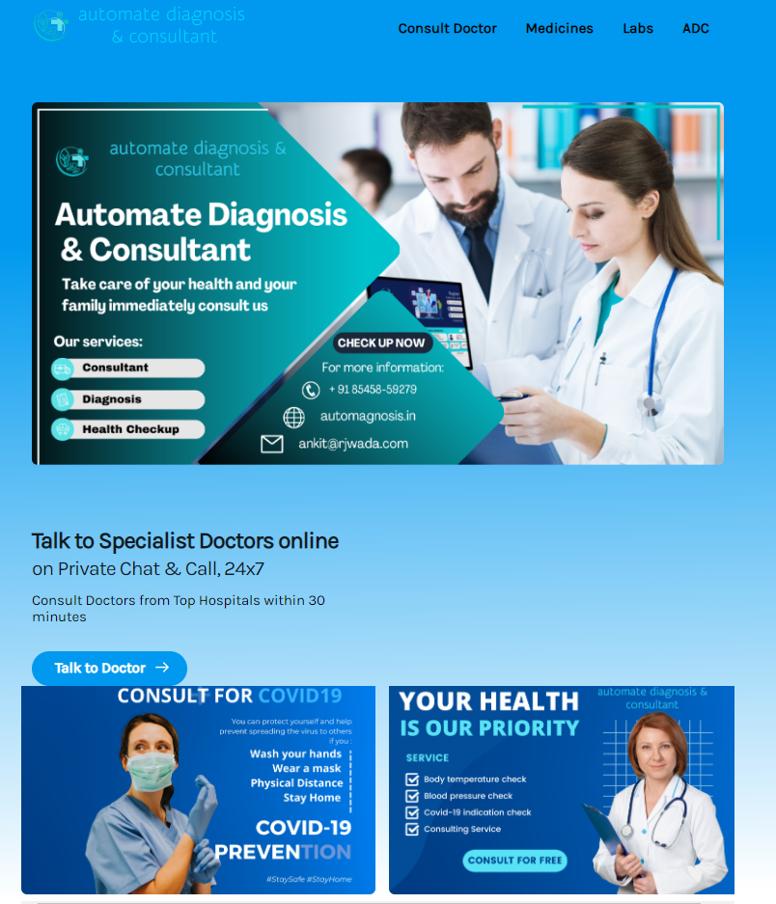

Fig 5.4: Snapshots of Consultant web application of Automate Diagnosis & Consultant.

The main purpose of a consultant web application is to facilitate the delivery of consulting services remotely, making it more convenient for both consultants and clients. This type of application is particularly useful for consultants who work independently or have a distributed team, as it enables them to connect with clients from anywhere in the world.

Consultant web applications typically have a user-friendly interface that allows clients to easily book appointments, communicate with their consultant, and share documents. The application may also include features such as project management tools, invoicing, and analytics to help consultants manage their business operations more efficiently.

Security is a critical consideration for consultant web applications, as they handle sensitive client information. These applications typically include measures such as encryption, two-factor authentication, and regular security audits to ensure that client data is protected from unauthorized access.

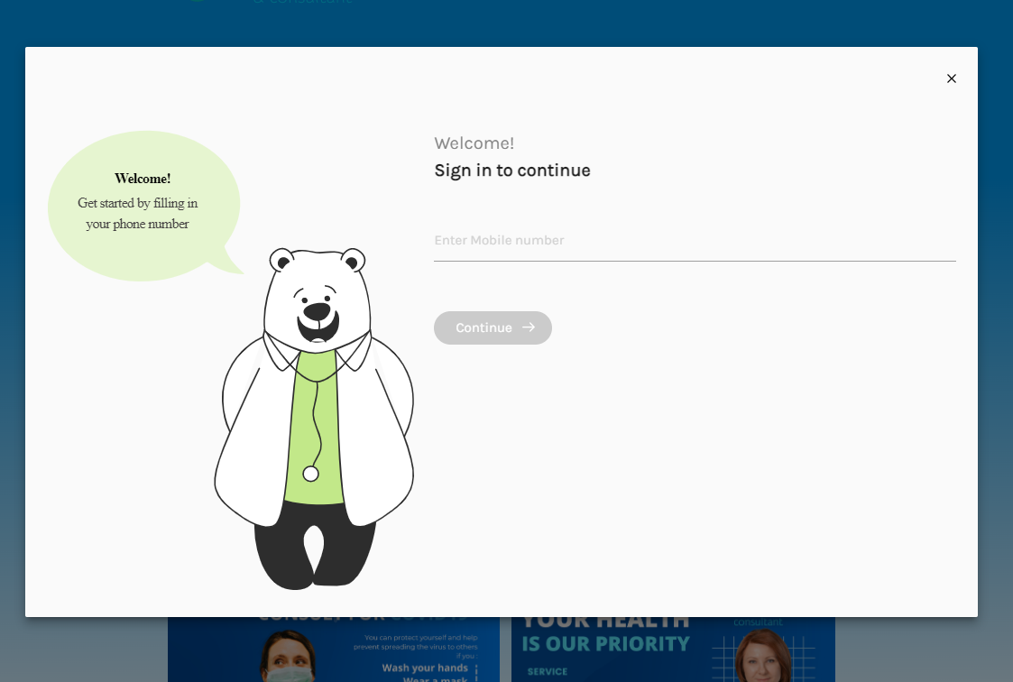

Fig 5.5: Snapshots of Login Module of Automate Diagnosis & Consultant with Mobile Number.

**Sign-In Module:** The sign-in module of an automated diagnosis system typically requires users to provide their mobile phone numbers for registration and verification purposes. This provides a secure way for users to access the system and protects their personal information. The sign-in module of an automated diagnosis

system typically requires users to provide their mobile phone number as part of the registration process.

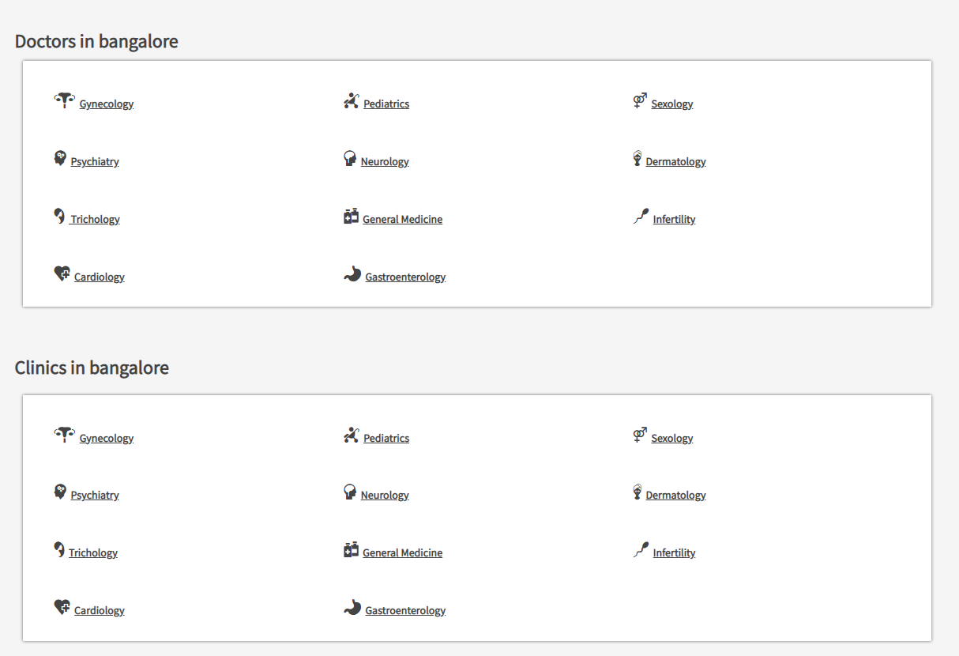

Fig 5.6: Snapshots of Doctor Search Module of Automate Diagnosis & Consultant

**Doctor Search by Hospital:** This feature enables users to search for doctors based on the hospital or medical facility they work in. Users can enter the name of the hospital or medical center they are interested in, and the system will display a list of doctors who work there. This feature is particularly useful for users who prefer to see a doctor associated with a specific hospital or medical center, or who may need to visit a doctor at a particular location due to travel or other reasons.

**Doctor Search by City**: This feature enables users to search for doctors based on their location. Users can enter the name of the city or zip code they are interested in, and the system will display a list of doctors who are in that area. This feature is particularly useful for users who are new to an area or who may be traveling and need to find a doctor nearby.

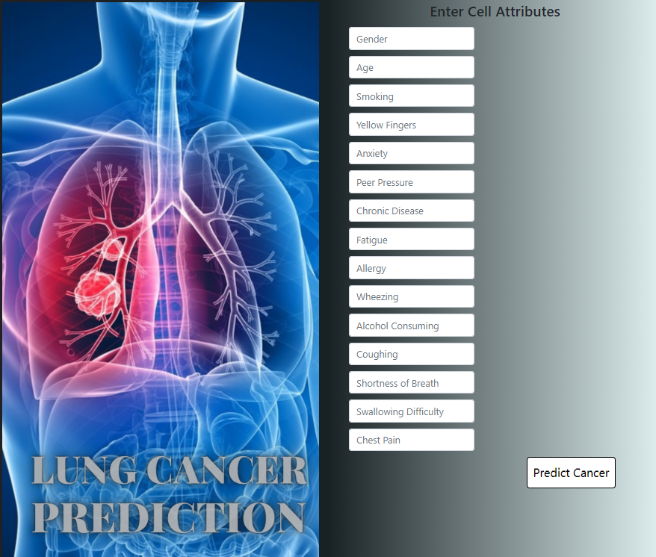

Fig 5.7: Snapshots of Lung Cancer Prediction Module of Automate Diagnosis

**Lung cancer prediction** is one feature in many automated diagnosis systems. These systems use machine learning algorithms and predictive models to analyze patient data and identify individuals who may be at high risk for developing lung cancer.

Prediction: Based on the data analysis, the system generates a prediction of the patient's likelihood of developing lung cancer. The prediction may be expressed as a probability, such as a percentage or risk score.

Recommendations: The system may provide recommendations for further testing or follow-up based on the predicted risk of lung cancer. For example, patients who are identified as high-risk may be advised to undergo additional screening tests, such as a chest X-ray or CT scan.

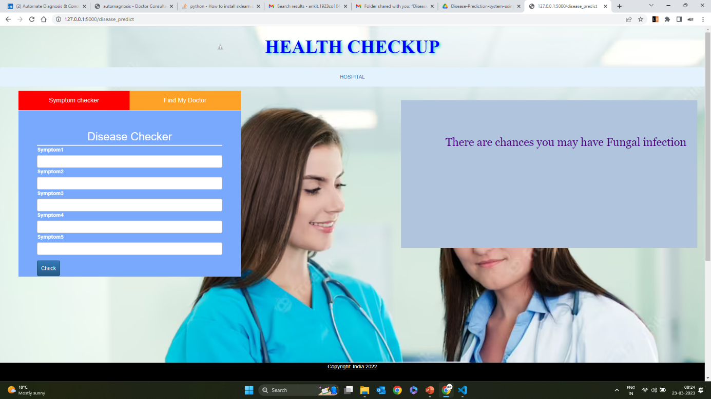

Fig 5.8: Snapshots of Multiple Disease Prediction Module of Automate Diagnosis

**Multiple Disease Prediction**: The website would use machine learning algorithms to analyze the user's data and generate predictions of the user's risk for multiple diseases, such as diabetes, heart disease, and cancer. These predictions would be displayed to the user in an easy-to-understand format, such as a risk score or percentage.

**Recommendations:** Based on the predicted risk for each disease, the website might provide recommendations to the user on how to reduce their risk, such as lifestyle changes or additional medical testing. The website might also provide information on the symptoms of each disease and how to detect them early.

**Follow-Up:** The website might offer follow-up services, such as regular check-ins or reminders for medical testing, to help users stay on top of their health and reduce their risk of developing serious disease

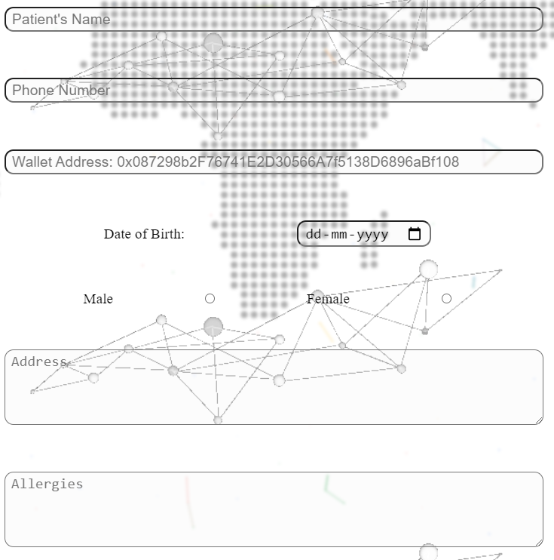

Fig 5.9: Snapshots of Add Patient Module of Automate Diagnosis

A web form with fields to collect patient information, such as name, age, gender, contact details, address, occupation, and medical history. Add a section in the form to capture the patient's symptoms. Make sure to cover a wide range of symptoms relevant to the condition being diagnosed. Include fields in the form to capture the patient's medical history, previous diagnoses, current medications, allergies, and any known genetic or hereditary conditions. You can use text fields or dropdown menus for this purpose. Implement functionality to submit the form data to a server-side script or an API endpoint. You can use JavaScript or a server-side programming language Node.js to handle the form submission.

Improve the user interface by adding validation to the form fields, providing error messages for invalid inputs, and offering clear instructions to guide users through the process. Consider using client-side scripting (e.g., JavaScript) to enhance the form's interactivity and user experience.

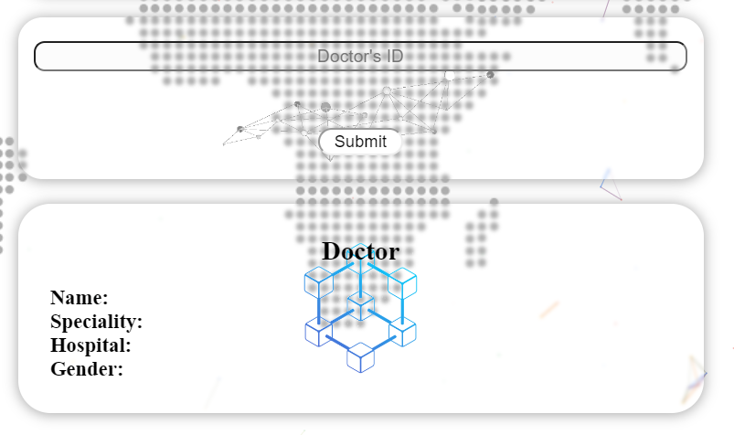

Fig 5.10: Snapshots of Add Doctor Module of Automate Diagnosis

Develop features to manage doctor records, such as updating existing records, deleting records, or searching for doctors based on specific criteria. Implement corresponding functionalities in the server-side script to handle these operations and update the database accordingly. Implement functionality to submit the form data to a server-side script or an API endpoint. You can use JavaScript or a server-side programming language Node.js to handle the form submission. Set up a database system to store doctor information. Choose a database management system MongoDB. Create a table or collection in the database to store the doctor data and define appropriate fields for each attribute. Implement functionality to retrieve doctor data from the database. This can be useful when displaying a list of available doctors or when performing specific operations on the doctor’s records.

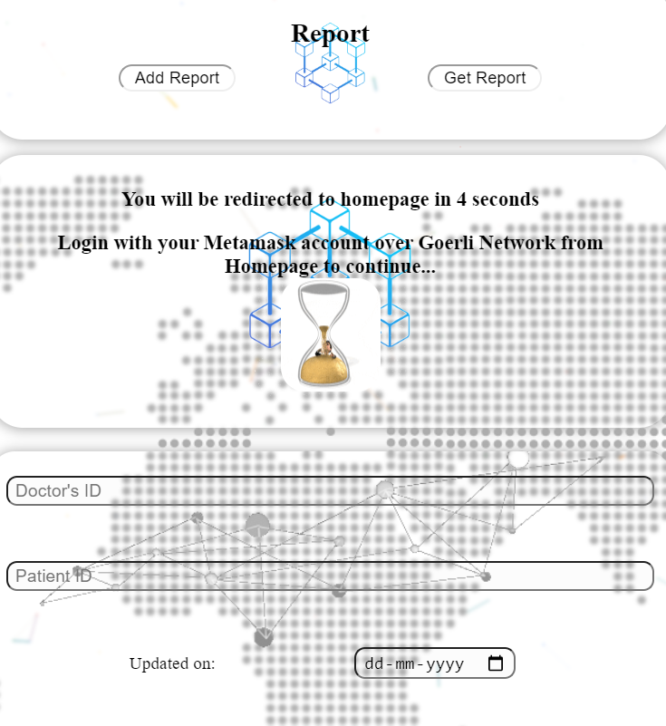

Fig 5.11: Snapshots of Add & Get Report Module via Patient ID & Doctor ID

Design the database schema to store the report data. Consider creating a table or collection to store reports with fields such as report ID, patient ID, Doctor ID, report content, date, and any other relevant information.

a web form with fields to input the patient ID, Doctor ID, and Report Content. Use HTML and CSS to design the form. Add validation to ensure that the required fields are filled correctly. Implement functionality to submit the form data to a server-side script or an API endpoint. Use JavaScript or a server-side programming language like Python, PHP, or Node.js to handle the form submission. In the server-side script, validate the submitted data and establish a connection to the database. Insert the report data, including the patient ID, Doctor ID, report content, and date, into the corresponding table or collection in the database.

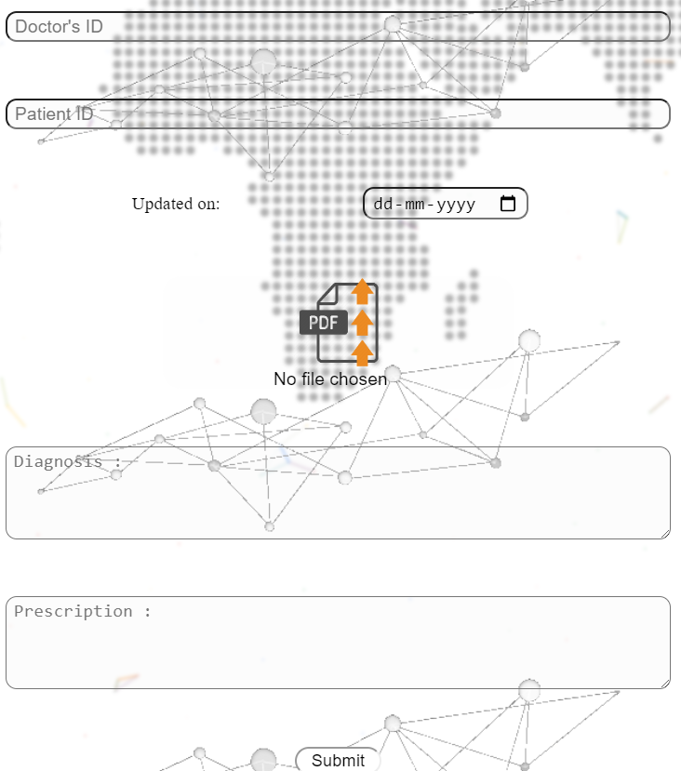

Fig 5.12: Snapshots of Report Module added by Path Labs in Decentralized format.

Implement a decentralized architecture, such as using blockchain technology, to ensure the secure and transparent storage and retrieval of reports. This can provide data integrity and eliminate the need for a centralized authority to manage and control the reports. Utilize smart contracts, which are self-executing contracts with predefined rules and conditions, to facilitate the interaction between the path labs and the automated diagnosis system. Smart contracts can automate the process of report generation, verification, and storage on the blockchain. Establish a connection between the path labs and the automated diagnosis system. Path labs should have a mechanism to securely transmit the report data to the blockchain network. This can be achieved using APIs, encrypted channels, or other secure communication protocols. Develop a system where the path labs can generate the report electronically. This could involve inputting relevant data, such as test results, diagnostic findings, and patient details, into a standardized format. Once the report is generated, it can be stored on the blockchain network using a unique identifier. Implement smart contracts to govern the report lifecycle. Smart contracts can define rules for report submission, verification, and access permissions. These contracts can also specify conditions for automated notifications or triggers based on specific events, such as report availability or result updates.

## CHAPTER 6

## CONCLUSION AND FUTURE SCOPE

**6.1 CONCLUSION**

As healthcare services are an important part of our society, automating these services lessen the burden on humans and diseases through the measuring process. Also, the transparency of this system helps patients to trust it. When the threshold value is reached, the alarm system that consists of a buzzer and LED alerts the doctor and they can act more quickly.

The IoT technology helps the server to update the patient data on the website. Many further improvements can be made to our system to make it better and easily adaptable such as adding more advanced sensors. The biometric information of the patient which is stored and published online & transmit to cellular can be given to scientists and researchers in medical fields to analyze the value and find patterns or for other research work.

Future work will focus on monitoring additional health-related parameters using a broader combination of transducers, sensors, and correlation techniques, and on improving system reliability and robustness to patient movement and connectivity losses.

.

**6.2 FUTURE SCOPE**

## The use of machine learning-based automated medical diagnosis has tremendous potential to enhance the healthcare infrastructure in the future. Some of the possible future scopes of this technology are Personalized Medicine: With the help of machine learning algorithms, it is possible to analyze a patient's health data to identify patterns and provide personalized treatment plans. This can lead to more accurate diagnoses and better outcomes for patients. Early Disease Detection: Machine learning can be used to identify early signs of diseases and predict their progression, allowing for earlier intervention and treatment. Medical Imaging: Machine learning algorithms can be used to analyze medical images, such as CT scans, MRIs, and X-rays, to provide accurate diagnoses and reduce the need for invasive procedures. Drug Discovery: Machine learning algorithms can be used to analyze large amounts of data from clinical trials and other sources to identify potential new drugs or repurpose existing drugs for new uses. Remote Patient Monitoring: Machine learning can be used to monitor patients remotely, allowing healthcare professionals to track patients' vital signs and other data in real-time and provide timely interventions when needed. Telemedicine: With the help of machine learning, telemedicine can be made more effective by providing patients with accurate diagnoses and treatment plans remotely. Patient Care Management: Machine learning algorithms can be used to identify patients at high risk of readmission and provide proactive care management to prevent readmissions. Resource Optimization: Machine learning algorithms can be used to optimize the use of resources, such as hospital beds, medical equipment, and staff, to improve efficiency and reduce costs. In conclusion, machine learning-based automated medical diagnosis has the potential to revolutionize the healthcare industry by improving patient outcomes, reducing costs, and enhancing the overall quality of care.

## LIST OF PUBLICATIONS

## The outcome of the project contains 2 publications:

## Patent

## 

## 2-Research Paper

H. Khatter, A. Yadav and A. Srivastava, "Machine Learning-Based Automated Medical Diagnosis for Healthcare," 2023 6th International Conference on Information Systems and Computer Networks (ISCON), Mathura, India, 2023, pp. 1-5, doi: 10.1109/ISCON57294.2023.10112144.

**The details of research paper are as follows:**

Title of Paper : Machine Learning-Based Automated Medical Diagnosis for

Healthcare

Conference Name : 6th International Conference on Information Systems and

Computer Networks (ISCON)

Conference Date : 3 -4 March 2023

Type : IEEE

Mode of Conference : Online

Proceedings : Available on IEEE explore

## REFERENCES

1. D. Fagella, Applications of Machine Learning in Pharma and Medicine, 2017, [online] accessed on 14 Nov 2022.
2. V. S. Pendyala and S. Figueira, "Automated Medical Diagnosis from Clinical Data," 2017 IEEE Third International Conference on Big Data Computing Service and Applications (BigDataService), 2017, pp. 185-190, doi: 10.1109/BigDataService.2017.14.
3. F. Santos, F. Silva and P. Georgieva, "Automated Diagnosis of Skin Lesions," 2020 IEEE 10th International Conference on Intelligent Systems (IS), 2020, pp. 545-550, doi: 10.1109/IS48319.2020.9200090.
4. V. Datla et al., "Automated clinical diagnosis: The role of content in various sections of a clinical document," 2017 IEEE International Conference on Bioinformatics and Biomedicine (BIBM), 2017, pp. 1004-1011, doi: 10.1109/BIBM.2017.8217794.
5. J. Siddiqi, B. Akhgar, A. Gruzdz, G. Zaefarian and A. Ihnatowicz, "Automated Diagnosis System to Support Colon Cancer Treatment: MATCH," Fifth International Conference on Information Technology: New Generations (itng 2008), 2008, pp. 201-205, doi: 10.1109/ITNG.2008.62.
6. P. Ongsulee, "Artificial intelligence, machine learning and deep learning," 2017 15th International Conference on ICT and Knowledge Engineering (ICT&KE), 2017, pp. 1-6, doi: 10.1109/ICTKE.2017.8259629.
7. R. Chellappa, S. Theodoridis and A. van Schaik, "Advances in Machine Learning and Deep Neural Networks," in Proceedings of the IEEE, vol. 109, no. 5, pp. 607-611, May 2021, doi: 10.1109/JPROC.2021.3072172.
8. F. Ertam and G. Aydın, "Data classification with deep learning using Tensorflow," 2017 International Conference on Computer Science and Engineering (UBMK), 2017, pp. 755-758, doi: 10.1109/UBMK.2017.8093521.
9. H. Božiković and M. Štula, "Web design — Past, present and future," 2018 41st International Convention on Information and Communication Technology, Electronics and Microelectronics (MIPRO), 2018, pp. 1476-1481, doi: 10.23919/MIPRO.2018.8400266.
10. D. S. Blyth, "Web page design for HTML (and friends)," IPCC 96: Communication on the Fast Track. IPCC 96 Proceedings, 1996, pp. 89-103, doi: 10.1109/IPCC.1996.552585.
11. H. Ran, W. Zhuo and X. Jianfeng, "Web Quality of Agile Web Development," 2009 IITA International Conference on Services Science, Management and Engineering, 2009, pp. 426-429, doi: 10.1109/SSME.2009.112.
12. S. Drobi, "Play2: A New Era of Web Application Development," in IEEE Internet Computing, vol. 16, no. 4, pp. 89-94, July-Aug. 2012, doi: 10.1109/MIC.2012.84.
13. H. Sugimura et al., "Development of immersive display system of web service in living space," 2014 IEEE 3rd Global Conference on Consumer Electronics (GCCE), 2014, pp. 49-50, doi: 10.1109/GCCE.2014.7031106.
14. N. Sandhya and K.R. Charanjeet, "A review on Machine Learning Techniques", International Journal on Recent and Innovation Trends in Computing and Communication, pp. 395-399, 2016, ISSN 2321-8169.
15. Harsh Khatter, Amit Kumar Gupta, Ruchi Rani Garg, and Mangal Sain. 2022. "Analysis of the S-ANFIS Algorithm for the Detection of Blood Infections Using Hybrid Computing" Electronics 11, no. 22: 3733.
16. Kanika Gupta, Nandita Goyal, Harsh Khatter "Optimal reduction of noise in image processing using collaborative inpainting filtering with Pillar K-Mean clustering", The Imaging Science Journal (2019), Vol. 67(2), pp:100-114, ISSN 1743-131X
17. Sharma, Sarang; Gupta, Sheifali; Gupta, Deepali; Juneja, Abhinav; Khatter, Harsh; Malik, Sapna; Bitsue, Zelalem Kiros “Deep Learning Model for Automatic Classification and Prediction of Brain Tumor”, Journal of Sensors (2022), Hindawi, Vol 2022(3065656), 8 April 2022.
18. Gunjan Raghav, Harsh Khatter, "Intelligent Curation Fuzzy Inference System for Blood Infections in Android”, IEEE 4th International Conference on Computational Intelligence & Communication Technology (CICT), 2018, Ghaziabad, India.
19. Vaishali Aggarwal, Harsh Khatter, Anil Kumar Ahlawat, “Performance analysis of the competitive learning algorithms on Gaussian data in automatic cluster selection”, 2nd IEEE International Conference CICT 2016, Feb 12-13 2016, ABES EC Ghaziabad.
20. Anjali Jain, Harsh Khatter, Rajesh Kumar Tewari, (2020) "Insight To Pandemic Covid-19: Analysis, Statistics and Prevention", Aegaeum Journal, Vol. 8 (7), pp: 551-561, ISSN 0776-3808 DOI:16.10089.AJ.2020.V8I7.285311.3758
21. Harsh Khatter, Amit Kumar Gupta, Ruchi Rani Garg, and Mangal Sain. 2022. "Analysis of the S-ANFIS Algorithm for the Detection of Blood Infections Using Hybrid Computing" Electronics 11, no. 22: 3733, 14 Nov 2022, <https://doi.org/10.3390/electronics11223733>
22. Harsh Khatter, Anil K Ahlawat, “An intelligent personalized web blog searching technique using fuzzy-based feedback recurrent neural network”. Soft Computing, 24, 9321–9333, 29 April 2020, (2020). <https://doi.org/10.1007/s00500-020-04891-y>
23. Harsh Khatter, Anjali Jain, Poonam Pandey, “Classification and Categorization of Blood Infection using Fuzzy Inference System”, International Journal of Soft Computing and Engineering (IJSCE), ISSN: 2231-2307, Volume-5 Issue-2, May 2015, pp. 95-97